|  |  |
| --- | --- |
|  | **Qatar University**  **College of Engineering**  **Department of Computer Science and Engineering** |

Senior Project Report

**Multi-facet online Shopping System Structuring**

**Project Group Members:**

Afnan Esameldin - 201201777  
Haya Nasser Al-Nuaimi - 201402885  
Inas Ibrahim Eissa - 201300268

**Supervisor**: Dr. Ali Jaoua

**2017**

This project report is submitted to the Department of Computer Science and Engineering of Qatar University in partial fulfillment of the requirements of the Senior Project cours

# Declaration

This report has not been submitted for any other degree at this or any other University. It is solely the work of us except where cited in the text or the Acknowledgements page. It describes work carried out by us for the capstone design project. We are aware of the university’s policy on plagiarism and the associated penalties and we declare that this report is the product of our own work.

Student: Afnan Esameldin Date: 23/5/2018

Signature:

Student: Haya Nasser Al-Nuaimi Date: 23/5/2018

Signature:

Student: Inas Ibrahim Eissa Date: 23/5/2018

Signature:

# Abstract

Nowadays people tend to use online shopping systems, since it provides guidance and useful feedback. The objective of this project is to design, implement, test and validate a multi-facet online shopping system. The target system should help users to have better shopping experience. Our system should also minimize the number of clicks for the users, help them to get more specific query and find their target product in a rational way.

Starting from existing online system such as Amazon, the purpose is to offer to the user different browsing trees depending on his/her preference. Advanced browsing should help the user to make best decisions during the purchase process. Customers should be able to view the structured results at run time starting from one or several attributes (i.e. price, category, description, mark, rank, etc.). The system should also display association rules to the user, within some support and confidence. This project should help sellers to improve the purchases and improve user experience by offering different attributes that can be helpful in their purchase. Obtained system should be tested and validated.

[add more details of how you evaluate system, eman ]

# Acknowledgment

We would like to thank all of those who supported us and made it achievable for us to end the project requirements easily and effectively. Special thanks to our supervisor Dr. Ali Jaoua, who never hesitated to help us during the entire semester. We are also very thankful for Dr. Ali research team, Mr. Aboubakr Aqle, Ms. Eman Rezk, and Mr. Fahad Islam for their infinite help and support.

This contribution was made possible by NPRP grant #07- 794-1-145 from the Qatar National Research Fund (a member of Qatar Foundation). The statements made herein are solely the responsibility of the authors.

Table of Contents

Declaration ii

Abstract iii

Acknowledgment iv

List of Figures vii

List of tables vii

1. Introduction and Motivation 8

2. Background and related work 9

2.1. Background 9

2.2. Related work 9

3. Requirements analysis 10

3.1. Functional requirements 10

3.2. Non-functional requirements 10

3.3. Ethical requirements 10

3.4. Assumptions 11

4. Solution Design 12

4.1. Overview 12

4.2. Architecture Diagram 12

4.3. Structural model 13

4.4. Behavioral model 13

4.5. Database design 13

4.6. User interface design 14

4.7. Design patterns 14

4.8. Hardware/software to be used 14

5. Implementation 15

6. Testing 16

7. Expected Impact 17

8. Conclusion 18

9. Future work 19

10. Student reflections 20

References 21

Appendix A – Project Plan 22

A.1. Project milestones 22

A.2. Project timeline 22

A.3. Anticipated risks 22

Other Appendices 23

# List of Figures

No table of figures entries found.

# List of tables

No table of figures entries found.

# Introduction and Motivation

## Problem statement

In our project, we are trying to solve the communal problem that we observed while conducting a survey on 200 persons. In figure [19], we noticed that only 10% of people can get their target item in about 5 minutes so in our system we are targeting the other 90% to get their desired item in an acceptable time using conceptual browsing algorithm. Multi-facet is a combination of a variety of features or perspectives. Our multi-facet system will help us to give a suitable interface and accurate results to the user in a minimum time.

While designing this project, we observed /solved some technical issues which are:

* Retrieving data from hidden database using API (Application Programming Interface).
* Writing an algorithm that will decompose the data in acceptable run time.
* Measuring the extracted rules using support and confidence from generated formal context using Apriori algorithm.
* Creating a tree interface for the user.
* Improving conceptual browsing algorithm to fit with our system (multi-facet).
* Searching different new algorithms like conceptual browsing algorithm, and Apriori algorithm.
* Understanding the mechanisms of APIs for different online shopping systems.
* Figure out the most important attributes to the users. (select some attributes).

We are expecting to face some challenges while developing this system like:

* Lack of theoretical knowledge.
* Lack of programming knowledge (language that we will use).
* Lack of management tools for SQLite database.
* The Amazon AWS (Amazon Web Services) gives low responsiveness with a free account. The subscription to a premium account will give better response time.

The web application goes through important stages which are:

1. Reading the query from the user.
2. Retrieving results from online shopping systems.
3. Saving data in our database.
4. Generating tree and rules.
5. Displaying result in an acceptable interface.

[Dr. tamer (show an example)]

## Project significance

The proposed project will focus on popular online marketplaces items. Those marketplaces provide websites with search capabilities, but the results are shown in a way that is not optimal to help the user to reach his/her target in an organized way. Our project has many benefits to the stakeholders. For us, it gives us the experience to work with hidden databases’ APIs. It also gives a benefit to the users by providing a helpful interface that divides the page into three parts; first part contains the facets that the user chooses according to the desired filter, second part includes the tree and the third part involves rules that are extracted from the formal context. This means that the user can see the results in a more organized way using a tree where he can navigate through different paths. If the user clicks on the leaf node, our system will route the user to the item in the provider page. Also, the user has the option to go and choose directly an item from the extracted rules. The combination of the algorithms in this project is what makes it unique and new in the region. The benefit of developing this project in Qatar and the Gulf region is that it is a new way of searching within text that significantly help to improve the user experience.

Project objectives:

The project objective is to create a web application, which is a structured view for the user to reach his desired item(s) with a minimum amount of time. The goal now is to apply it to Amazon and it might be extended to eBay and other online shopping systems. The user submits a query to our system search box, the system will get the user input and search for it on different online shopping systems. It should then store the retrieved data in a SQLite database. After that multi-facets box, tree and extracted rules will appear to the user. The user chooses one or more attributes for browsing in the tree in a multi-facet way. He is also able to go through different paths in the tree until finding the desired items. The user may also select an item from the set of rules to make better and shorter item selections.

# Background and related work

## Background

### Extracting Data from Online Systems with Hidden Database:

One important originality of our project is the context of a hidden database; since APIs offered by the online systems give limited access to the database and only top k results. Although most of the online shopping system hidden databases can be access through a specific provided APIs at query time [8]. APIs are query interfaces that act as a channel to access the source databases [1]. For example, Amazon offers some services that enable us to read from their source database when you register for Product Advertising APIs. But there are some Security Credentials that AWS declines the attempt in case of temporary overloading and response with 503 error code. We overcome this problem by giving time between each request. Using the Product Advertising APIs feature, we can send a request through calling an HTTP (Hypertext Transfer Protocol) GET method using name-value pairs, which are:

1. Endpoint = http://ecs.Amazonaws.com/onca/xml?
2. AWSAccessKeyId = xxxxxxxxxxxxxxxxxxxxx (specific key to each registered user)
3. AssociateTag =xxxxxxxxxxxxxxxxxxxxxx (tag to each registered user)
4. Version =2009-03-31
5. Operation =ItemSearch (type of operations provided by Amazon)
6. ResponseGroup = Large (to enlarge the number of attributes)
7. SearchIndex =Electronics (targeted category for our project)

The received response is obtained in an XML (Extensible Markup Language) format as shown in Figure 1. The XML document contains many attributes regarding the stored items as well as the header of the request. The retrieved data is reflected as an instance of Amazon’s product database since it is only a fraction of the whole database, this is considered as an issue since we need to estimate this fraction.

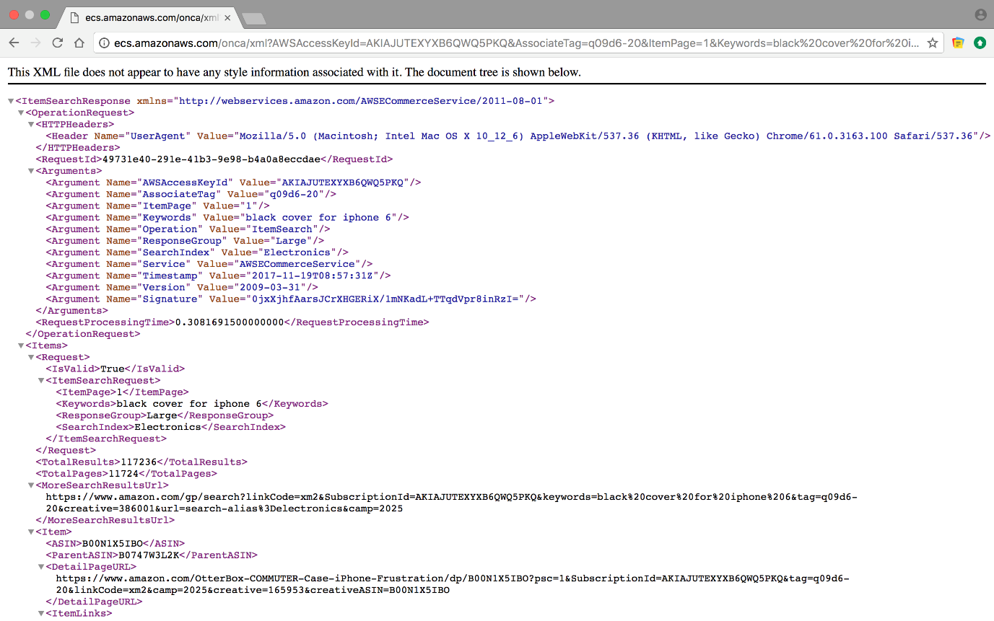

##### Figure . Amazon AWS API retrieved attributes

### Formal concept analysis (FCA) / Apriori Algorithm:

Formal Concept Analysis is a theory of data analysis based on discrete mathematics . This includes concept hierarchy from a collection of objects and their properties [3]. It has been developed as an area of applied mathematics grounded on building a mathematical model of concepts and concepts hierarchy. The approach takes an input binary matrix called formal context identifying a set of column attributes and row objects, finds the natural concepts defined in the data, and then arranges the concepts in a fractional order structure [7]. Each concept is a pair of objects and attributes that are maximally associated with each other. A table with logical attributes can be represented by a triplet (O, A, I) where I is a binary relation between O and A. Elements of O are called objects and correspond to table rows, elements of A are called attributes and correspond to table columns. For example, the equivalent table (O, A, I) is given by O = {O1, O2, O3}, A = {A1, A2, A3} and we have (O1, A1) ∈ I, (O2, A3) ∉ I as shown in Table 1.

###### Table . Binary Context

|  |  |  |  |
| --- | --- | --- | --- |
|  | A1 | A2 | A3 |
| O1 | 1 | 1 | 1 |
| O2 | 1 | 1 | 0 |
| O3 | 0 | 1 | 1 |

**Apriori algorithm**

The Apriori Algorithm is a persuasive algorithm for extracting frequent item sets for Boolean association rules. Apriori utilizes a " bottom-up" approach, where common subsets are stretched by single item at any given moment in a step called Candidate generation, then candidates are examined alongside the data. Apriori is intended to work on a database having transactions (for instance, accumulations of items purchased by clients). The algorithm mainly consists of two stages; applying minimum support to locate all the frequent sets with k items in a database, then using the self-join rule to discover the frequent sets with k+1 items with the assistance of frequent k-item sets [21]. Reiterate the two stages from k=1 till we are incapable to apply the self-join rule (a rule to find 𝐿k, a set of candidate k-item sets is generated by joining 𝐿k-1 with itself.) [21]. After generating the association rules, there are three definitions to measure them, support, confidence and calling frequent item set. Support is the relevancy of the association rule, while confidence is the reliability of the association rule, additionally calling frequent item set is when the item set support(X) is bigger than the threshold minsup. Let K = (G, M, I) be a context, where G is a set of objects, M is a set of attributes (items), I $⊆$ G x M. An association rule of the context K is an expression A $→$ B, where A, B $⊆$ M and (usually) A $∩$ B= $∅$ [21]. Apriori algorithm flow chart is shown below in Figure 2.

A’ = F (A), if A is included in G (the set of objects)

A’ is the set of attributes shared by all objects belonging to A.

B’=G (B) if B is included in M (set of attributes)

B’ is the set of objects sharing all attributes in B.

Support (A $→$ B) = $\frac{\left|(A∪B)'\right|}{\left|G\right|}$

confidence (A $→$ B) = $\frac{\left|(A∪B)'\right|}{\left|A'\right|}$

add example

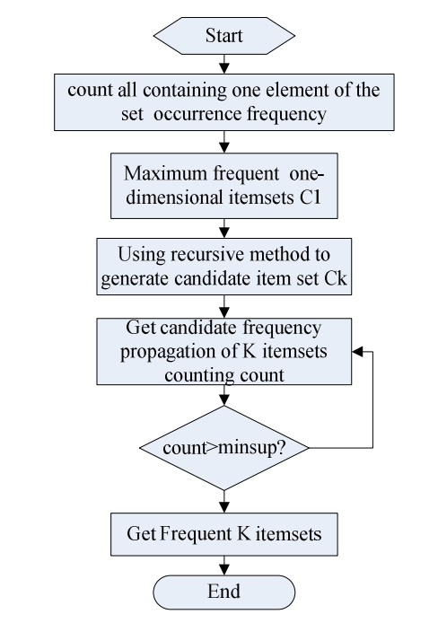

Is that really a flow chart??? Algorithm steps

##### Figure 2. Apriori Algorithm flowchart

### Stemming and Lemmatization

Distinctive types of a word frequently convey basically a similar meaning [9]. For example, there is most likely no distinction in intent between a query for that and a look for hats. These syntactic contrasts between word frames are called inflections, and they make a difficult task for query comprehension.

To avoid the variation of the inflections of words to affect the quality and the accuracy of the results we use the concept of Stemming and Lemmatization to get the most important keywords from the data. A similar root, for instance ‘covering’ is got from the stem or the root ‘cover’. So also, the word ‘offering’ gets from the verb ‘offer’. When dealing with a query, it is important to check every one of the expressions of similar origin and meaning to guarantee the pertinence and precision of the outcomes that will be recovered [17]. Stemma manages cutting the last couple of letters of a word to diminish the word back to its root, for example, ‘buying’ would progress toward becoming ‘buy’. Moreover, lemmatization is concerned about the base of the word, it forms a set of related words like, the lemma of {paying, paid, pays} is pay. These strategies are utilized while building the term dictionary, by operating using porter’s algorithm to each term, while processing the queries to find a match in the dictionary.

**Porter Stemmer Algorithm**

The porter stemmer algorithm is a standout stemmer algorithm among stemmer algorithms like Lovins stemmer. It is an algorithm designed for removing the commoner morphological and inflectional endings from words in English, where they are removed by some standard removal rules [9]. In the first phase, a decrease rule is picked among a gathering based on the size of the suffix, these rules are

**Rule Example**

SSES → SS caresses → caress

IES → I ponies → poni

SS → SS caress → caress

S → cats → cat

There is additionally another approach to check for a suffix. For instance, the word “devotement”. There is a rule mentioned in Porter’s algorithm state that; if the term ends with “ement”, calculate the characters that prior “ement”, if the number of characters are bigger than one; then we eliminate “ement”. As a result, the word “devotement” will be “devot”. If the number of characters is one or less, it will remain the same [9].

### Conceptual Browsing tree algorithm

The conceptual browsing tree algorithm used the hyper concepts method to extract concepts from the binary matrix to form a tree. The hyper concept method has a complexity of O (mn3), where n is the number of attributes and m is the number of objects. In the tree each concept acts as a node in the tree and each item acts as a leaf node. For example, referring to the Table 1 using the Conceptual Browsing Algorithm we have demonstrated the steps needed to form the tree. First, we compute the binary relation related to the objects. Then we calculate the maximum Hyper-Concepts(HC) and the relations. We are trying to find the minimal coverage of the formal context by a set of HCs covering the whole context. We can then decompose each HC in that level to move a level deeper by avoiding the repeated selection of chosen words [16].

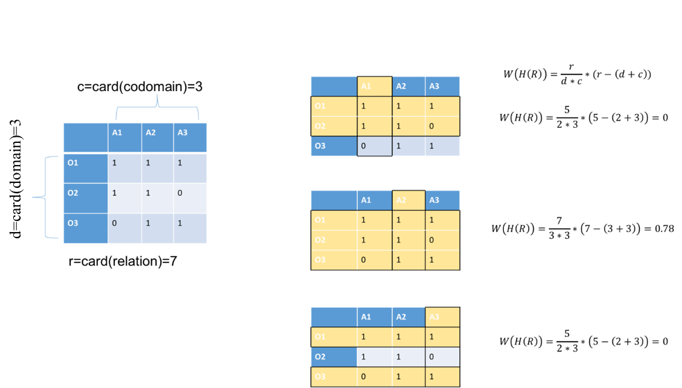

##### Figure 3. Compute Hyper Concept for each attribute

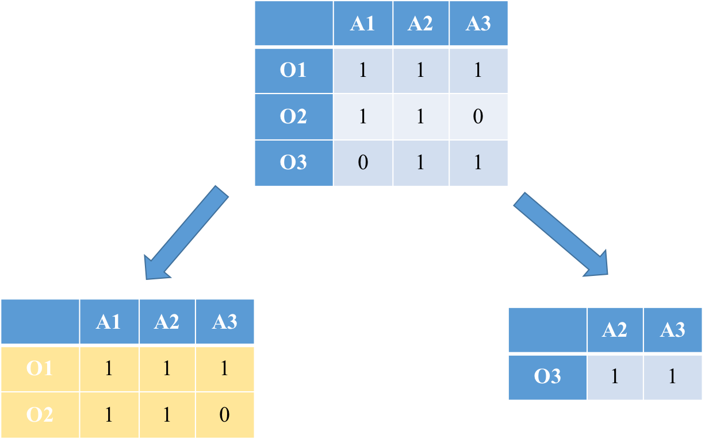

##### Figure 4. Hyper Concept Tree construction

## Related work

A lot of discussions and researches have been done for enhancing user experience in online shopping. Our project is closely related to the following topics: Multi-facets structuring system, Structuring result into trees, rule generation and entity extraction.

[2] MOBILE APP FOR HIDDEN DATA ANALYTICS OF ONLINE MARKETPLACE SYSTEMS

The aim of this research is providing a good interface to the user to help them to shop online by offering an Android application using the tree structure, the interface is minimized to only two navigation screens. A set of APIs were used to help to extract hidden data from several online marketplaces such as Amazon and eBay. Moreover, the implementation done using Java programming language and all responses are received in XML format. This paper is limited because the tree will be made based on only one attribute which is the item descriptor. In fact, the difference between this system and our system is that we have chosen the most important attributes for the user to achieve the shoppers' goal. Therefore, by using multi-facets we will gain the user satisfaction. We will also generate rules based on item’s attribute to help user to get all the items that are related to the searched item

[12] TEXT SUMMARIZATION BASED ON CONCEPTUAL DATA CLASSIFICATION

In this paper, the authors discussed the Conceptual Browser Tree. The aim of this paper is to get summary and correlate keywords in the document. First, creating a binary context containing objects (sentences) and properties (words). Then, after ignoring empty words, they get the optimal concept by finding the maximum weight from the binary context and generate summary keywords. An extension of this work has been done in [22] where authors used a decomposition algorithm to build a browsing tree.

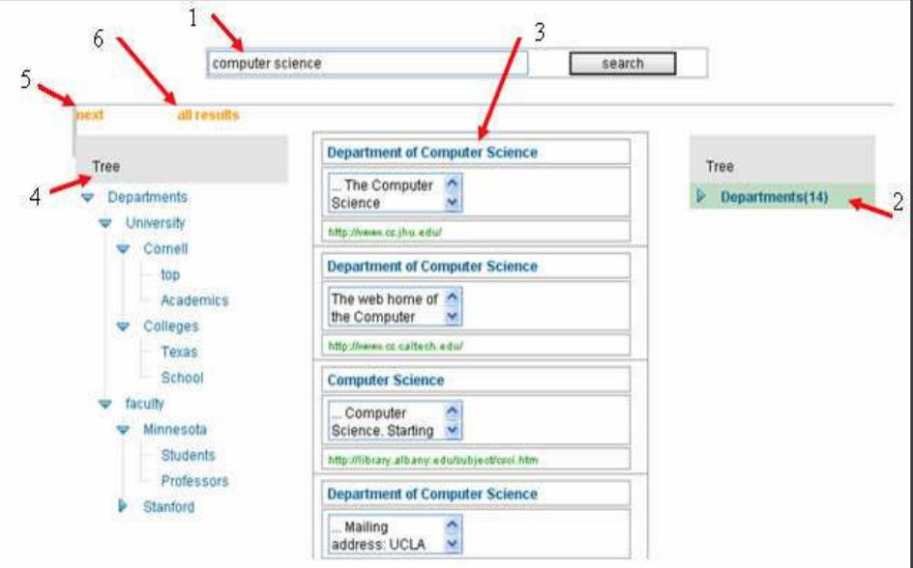

Not clear

##### Figure 5. A view of Browsing tree [22]

In our system, we used formal context which represents the items as objects and their corresponding attributes as properties. This is done after we get results from online shopping system like Amazon using API as shown in Figure 6 below:

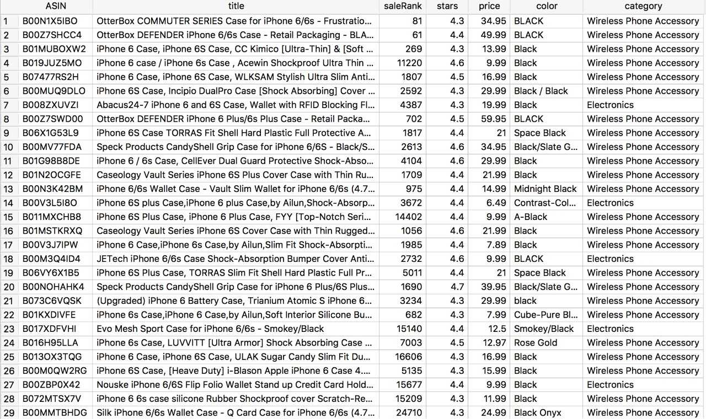

##### Figure 6. Retrieved data from Amazon

###### Table . Binary Relationship of retrieved data from Amazon

|  |  |  |  |  |  |  |  |  |  |  |  |
| --- | --- | --- | --- | --- | --- | --- | --- | --- | --- | --- | --- |
|  | S1 | S2 | S3 | S4 | S5 | Hprice | Mprice | Lprice | Hsale | Msale | Lsale |
| Item 1 | 0 | 0 | 0 | 1 | 0 | 1 | 0 | 0 | 0 | 1 | 0 |
| Item 2 | 0 | 0 | 0 | 1 | 0 | 1 | 0 | 0 | 0 | 1 | 0 |
| Item 3 | 0 | 0 | 0 | 1 | 0 | 0 | 1 | 0 | 0 | 0 | 1 |
| Item 4 | 0 | 0 | 0 | 1 | 0 | 0 | 1 | 0 | 0 | 0 | 1 |

We can easily discover the formal concepts from the above formal context. For example,

{item 1, item 2} {S4, Hprice, Msale}

{Item 3, item 4} {s4, Mprice,Lsale}

[13] FACETEDPEDIA: DYNAMIC GENERATION OF QUERY-DEPENDENT FACETED INTERFACES FOR WIKIPEDIA

The research is concentrated on forming facet interface to help the user navigate through the resulted articles. This system will make the query generation easy for article researchers from Wikipedia. The user only enters the keyword, then, Facetedpedia will provide categorized facets and each contains facets that will provide a list of articles. The facets are groups based on diverse views of the articles. In this paper, they used articles attributes to form facets. First, the system collects articles, then extract article attributes and group them by category, afterward organize them by hierarchy facet category (HCF), lastly rank them. Although the system provides a dynamical generation of query-depended facets, the process is slightly time-consuming and unsteady. In this paper they gathered the data by downloading Wikipedia dump which is a complete copy of all Wikipedia wikis in XML format, they do not have a client-server interaction with Wikipedia. In fact, the difference between this research and our system is that we have multiple providers for the data, but they only use Wikipedia as the main source. On top of that, we have a direct connection with the providers since we are using APIs to get the last version of the data. They did not provide any kind of rules that will help the user to visualize the connection between facets.

[11] INCREMENTAL PSEUDO RECTANGULAR ORGANIZATION OF INFORMATION RELATIVE TO A DOMAIN

The authors introduce a new method that uses a formal concept decomposition. This method helps to come up with a system based on algorithms that handle incremental changes to information via addition operation. The aim of this paper is to manage incremental information organization and structuring in a dynamic environment in a reasonable time. Where to optimize the complexity, in forming the new browsing tree they use an incremental organization (i.e. update the browsing tree without recompiling the whole data). Using Incremental Pseudo Rectangular Organization can be beneficial to our project where we update the tree whenever a facet is selected. It will improve our system since it supports scalability of data. Also, it gives our system the capability of delivering updates to the end users in a short time.

[15] STRUCTURED BROWSER OF THE DEEP WEB THROUGH SMALL SCREENS

The aim of this paper is to design and implement a structured conceptual browser for small screens. It deals with Arabic and English queries. It uses the tree to structure the retrieved results from Google. The goal of this research is to minimize the number of clicks for the user by reading the document and provide structured results, where the user will be able to navigate through the tree until he/she reaches his/her goal. In fact, the similarity between this system and ours is the features, but we have a more improved system that will get the better satisfaction of the user since our system is aiming to:

1. Minimize the user clicks.
2. Minimize time to reach the goal.
3. Represent results in a structured way.
4. Allow the user to navigate through different paths.
5. Retrieved data from multiple providers.
6. Querying using multi-facets.

Please refer to the demo-paper I have presented in ICDE 2018 in Paris

<https://www.youtube.com/watch?v=W3x1Hdb3jaM&feature=youtu.be>

present some screens

At the end, Table 3 shows a comparison between the research papers and our system.

###### Table . Comparison of research papers

|  |  |  |  |  |
| --- | --- | --- | --- | --- |
|  | Mobile App for Hidden Data Analytics of Online Marketplaces Systems [2] | Facetedpedia [13] | Structured browser of the deep web through small screens [15] | Multi-facets online Shopping System Structuring |
| Multi-providers | √ |  |  | √ |
| Multi-facets |  | √ |  | √ |
| Extracting rules |  |  |  | √ |
| Use tree structure | √ |  | √ | √ |
| Extract data using APIs | √ |  |  | √ |
| Web application |  | √ |  | √ |
| Multiple  Language |  |  | √ |  |

# Requirements analysis

## Functional requirements

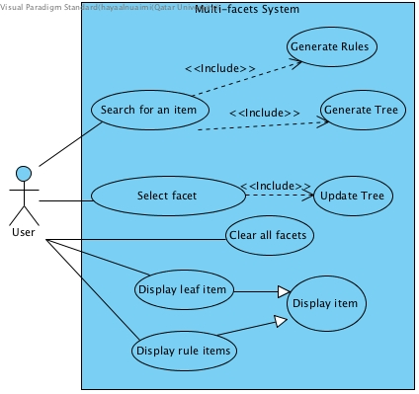

##### Figure 7. Use cases diagram

###### Table 4. Use cases summary

|  |  |
| --- | --- |
| Use case | Brief description |
| Search for an item | Searching for an item, retrieve it and store its attributes in the database. |
| Select facet | Select the facet that the user wants to refine the result with. |
| Generate tree | Generate tree based on user’s keyword/s typed in the search box. |
| Generate rules | Generate rules and display them to the user. |
| Display leaf item | Display the tree leaf item. |
| Display rule item | Display item that satisfies the selected rule. |
| Display item | Display an item on the provider page. |
| Update Tree | Generate tree based on user facet selection. |
| Clear facet | Clear all user’s previous selection. |

## Non-functional requirements

###### Table 5: non-functional requirements

|  |  |
| --- | --- |
| 1. Scalability: | The system can handle a lot of users at the current time, as it depends on the online system. For example, when dealing with data retrieved from Amazon and eBay, our system inherits the scalability from Amazon AWS and eBay. Each user has different sessions … |
| 1. Modifiability: | More new attributes would be added to the system, some existing ones maybe be modified or removed to enhance further capabilities. The ability of the system to handle such modifications shows that the system is easily upgradable, and easily modified without changing or disrupting system interfaces. |
| 1. Portability: | As the program is written in Java, and Java is a platform independent language so, the system could run on a variety of operating systems. Which means that it is not specific or bounded to a certain platform, hence portable. For example, Amazon AWS response in XML format and this format is portable to be parsed. |
| 1. Availability: | The project depends on data from online providers, so the system will be available as long as they are. In general, the system is available to the users most of the time. |
| 1. Performance: | The project performance depends on Amazon AWS and eBay since we are running a free version and there might be some limitation in the response. |
| 1. Legal: | We use free versions of Amazon AWS API and eBay API for online shopping system are used to implement the project.  Java language used in the project is free language. |
| 1. Usable: | The web application is easy to use, and the users can easily be familiarized with the interface. |
| 1. Easy to use Interface: | Very easy interface, the user can get familiar with. |

## Professional Code of Ethics

###### Table 6: Code of ethics

|  |  |  |
| --- | --- | --- |
| IEEE [10] | ACM (Software Eng.) [19] | Project point of view |
|  | “3.13. Be careful to use only accurate data derived by ethical and lawful means and use it only in ways properly authorized.” | While developing the program, we might use Amazon AWS APIs, and possibly other marketplaces APIs. To read or download different types of documents, hence all resources and references used in this project are cited. |
|  | “5.09. Ensure that there is a fair agreement concerning ownership of any software, processes, research, writing, or other intellectual property to which a software engineer has contributed.” | A credit is given to all people who contributed to this project. |
|  | “2.01. Provide service in their areas of competence, being honest and forthright about any limitations of their experience and education.” | - The work done to achieve the project goal is accomplished by students.  - The results and limitations of the system will be discussed honestly without any concealment. |
|  | “6.08. Take responsibility for detecting, correcting, and reporting errors in software and associated documents on which they work.” | An evaluation of the web application and its performance will be carried out periodically to detect and then correct any errors that might arise later. |
| “7. To seek, accept, and offer honest criticism of technical work, to acknowledge and correct errors, and to credit properly the contributions of others.” |  | Accept criticism of the supervisor, and examiners, and use the comments to improve the design accordingly. |
| “8. to treat fairly all persons and to not engage in acts of discrimination based on race, religion, gender, disability, age, national origin, sexual orientation, gender identity, or gender expression.” | “7.05. Give a fair hearing to the opinions, concerns, or complaints of a colleague.” | - The system is designed to be used and benefits any users who need it, regardless of any factor of race.  - The relationship among project team is based on respect and collaboration. |

## Assumptions

We assume that:

•      The data of the providers are available.

•      The tree will be always based on the keyword that the user entered.

* Each page has fixed number of items retrieved from amazon an eBay

•       the tree will be filtered by the facets in contradiction with the rules where they are based on the whole context.

# Proposed Solution

## Possible solutions and tradeoffs

Our project has various stages and each stage can be defined as a subproject. Every stage has a different methodology. The first stage is about extracting data from providers; the only way is by using APIs. Since the attributes provided from Amazon are different from eBay, so there is an option where we can either stick to one provider and have all the attributes as filters or compromise and add another provider but there is a tradeoff. Hence the more providers the less the number of common attributes.

The second stage is scaling the data that includes converting the data to a binary dataset. There are many types of scaling based on the type of attributes: Nominal scaling, Dichotomic scaling, and Ordinal scale. For example, this many-valued context of university majors can be scaled using several types of scaling.

Table 7: Many-valued context of university majors

|  |  |  |  |
| --- | --- | --- | --- |
| Id | Gender | Age | Major |
| 1 | F | 19 | Computer Science |
| 2 | M | 20 | Computer Engineering |
| 3 | M | 19 | Computer Science |
| 4 | F | 25 | Business |

For long-string-descripted attributes, we can use Porter algorithm to stem each word in the string. These stems will be provided as attributes to the scaling algorithm. Porter Algorithm uses stemming to make the scaling better and more accurate with a minimum number of clusters/stems. On the other hand, Lancaster stemmer is the most aggressive stemming algorithm, since the word stems become too short that they are barely readable by a human anymore.

Nominal scaling can be used for “Major” attribute; this type of scaling is appropriate for the binary representation of nominal attributes. We can take advantage of Porter algorithm as mentioned above to subdivide the string into its individual stems. A specific situation of nominal scaling is Dichotomic scaling [4], that is appropriate for attributes with dual similar values like “on” and “off “, this can be used for “Gender” attribute. The Ordinal scale can be used for “Age” attribute; since it scales based on real number ranges. The resulting scaled context for our university majors example is shown below in Table 8.

Table 8: Scaled Many-value context of university majors

|  |  |  |  |  |  |  |  |  |
| --- | --- | --- | --- | --- | --- | --- | --- | --- |
| Id | F | M | ≤25 | ≤20 | ≤19 | Computer Science | Computer Engineering | Business |
| 1 | 1 | 0 | 1 | 1 | 1 | 1 | 0 | 0 |
| 2 | 0 | 1 | 0 | 1 | 1 | 0 | 1 | 0 |
| 3 | 0 | 1 | 1 | 1 | 1 | 1 | 0 | 0 |
| 4 | 1 | 0 | 0 | 0 | 1 | 0 | 0 | 1 |

The third stage, Matrix Factorization; extracting concepts from the binary matrix. There are some existing techniques, like, Non-Negative Matrix Factorization (NMF), Boolean Matrix Factorization (BMF); however, they were not fully studied to be used in the framework of Information Retrieval and modern Data Analysis [4].

BMF is a breakdown of the original matrix L ∈ {0,1} n×m, where Lij ∈ {0,1}, into a Boolean matrix product P ◦ Q of binary matrices P ∈ {0, 1} n×k and Q ∈ {0, 1} k×m for the smallest possible number of k [4]. After that building a conceptual browser tree; build a tree based on concepts using heap data-structure.

The fourth stage, generating association rules, mainly this is a market basket analysis problem and the most efficient proposed algorithm is Apriori, since it gives the minimal number of rules [4]. Suppose the number of unique elements in a relation is donated by R, the input transactions is N and the threshold is M. Hence the complexity of Apriori Algorithm is given as: $O(2^{M})$.

Another algorithm for extracting rules is Galois connection that can be defined as:

Let <G, I, M> be a context, where n=|G| the number of objects and m=|M| is the number of attributes. Galois Connection is composed of two functions with known properties:

f: $2^{G} →2^{M}$

g: $2^{M} →2^{G}$

Assume that A belongs to $2^{G}$ is a subset of objects: Let B= F(A). If |A|=p, and a context (G, I, M), building B requires p*m conjunctions where m is the number of attributes. Let q=|B|. From B we can build G(B) requiring n*q conjunctions where q is the number of attributes of subset B and n the number of objects. The complexities of the two operators are respectively O(pm) and O(qn). So The complexity of the closures G(F(A)) is O(pm) + O(qn). The complexity of the Galois connection $O (nm\})$. Galois connection is hard to implement and will not find the minimum number of rules.

There is another type of Apriori algorithm called AprioriTID which is basically Apriori but it passes through the data once. AprioriTID requires more space since it stores additional data structures [20]. Another possible algorithm to use is Clustering; it is the process of making a group of abstract objects into classes of similar objects. Clustering is capable to be beneficial on any kind of data such as binary data, numerical data and categorical [5]. On which there are many clustering methods such as partitioning and hierarchical. The Hierarchical method has two approaches Agglomerative (bottom-up) approach and Divisive (top-down) approach.

Lastly the Platform, there are 3 types of platforms: Desktop application, web application or Mobile application. The differences between them can be better represented in Table 9.

Table 9: Platform comparison

|  |  |  |
| --- | --- | --- |
|  | Advantages | Disadvantages |
| Desktop application | * More powerful. * **Responsive** in time matter. * Easily designed. | * **Localized**. * **Platform dependent**; application must be developed for and installed on a particular operating system. |
| Web application | * **Portable**; The user can access the application through web browser. * **Responsive** in design matter; on each different device there will be different design can be implemented using BootStrap [14]. * **Platform independent**; for clients. | * **Problem in Scalability**; needed to be taken into consideration while development. * **Performance**; need powerful hardware. * **Connectivity**; network problems can occur; while connecting to server. |
| Mobile application | * **Portable**. * **Responsive** in design matter; on each different device there will be different design can be implemented using BootStrap [14]. | * **Platform dependent**;(Android applications can’t run on IOS devices and vice versa). * **Performance**; need powerful hardware; since till now mobile hardware is not comparable to laptops. * **Connectivity**; network problems can occur; while connecting to server. |

## Selected Solution overview

Our project has different stages and we are aiming to choose the most suitable way to implement it. In the first stage, we are going to extract data from the provider database by using their APIs. In terms of attributes, we chose the most four important attributes for the user based on the survey and our personal shopping experiences, which are price, sale rank, category and stars. We found that only price and category are common in both providers. So we stated that we will use all four as filters where only stars and sale rank are applicable only for Amazon. Detailed description of retrieved data is mentioned in section 2.1.1.

Secondly, in scaling, we are going to use nominal scaling for the item’s title by taking advantage of Porter algorithm to stem each word in the title. We preferred using Porter algorithm because it is the most commonly used stemmer, the figure shows the steps of the algorithm.

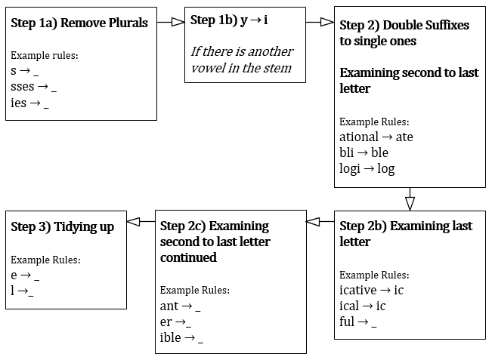

Figure 8. Porter Algorithm Steps

The ordinal scale is important to us since most of our data are real numbers. Moreover, we customized the ordinal scaling based on the attributes minimum and maximum. For example, in the price attribute we calculated the minimum, maximum and the range (difference between maximum and minimum), then used the equations shown below. Hence, we can have three equally divided clusters.

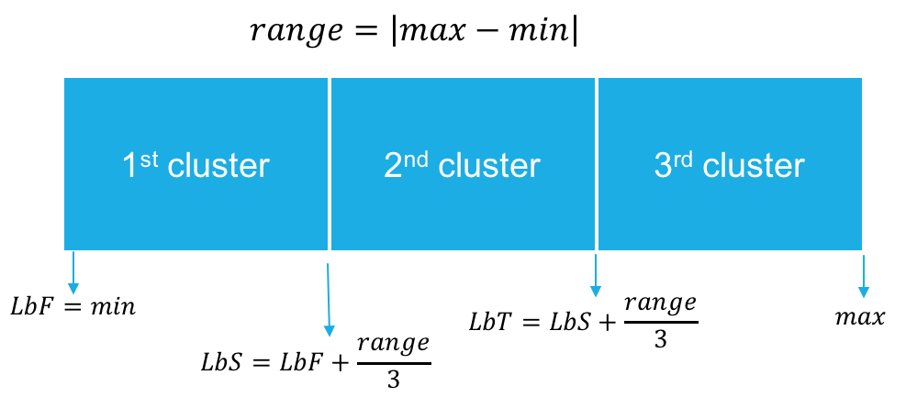

The third stage, extracting concepts from the binary matrix using BMF since it is the only factorization technique that is fully studied to be used in the context of information retrieval and modern data analysis. After that, we are going to use conceptual browsing tree algorithm to build our tree of concepts. The fourth stage, generating association rules, the most efficient proposed algorithm is Apriori algorithm, because it gives the minimum number of rules [18].

Lastly in terms of platform, we chose to build a web application hence it’s portable, responsive in design, platform independent and it reaches our client’s need based on a survey we conducted. The survey showed that 55% of the people who conducted the survey prefer shopping using a website rather than other platforms.

We can reuse open sources and adapt them to our multi-facet. It would be a better usability since we can take advantage of other people work rather than building all algorithms from scratch then modify it to benefit our target.

**Life Cycle:**

Our system should provide high maintainability, performance, and accuracy. Therefore, spiral model has been used in our system to easily modify in case of failure or improve the system in the future.

The Spiral life cycle model is a type of iterative software development model. This model combines the features of both, prototype model and waterfall model. In Spiral model each iteration represents a stage of our system (and we can have any number of iterations according to the project). Each iteration has four sections: determine objectives, risk analysis, testing, and evaluation. Figure 9 illustrates these sections.

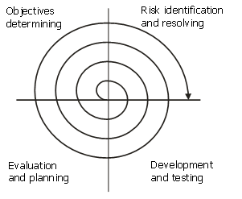

##### Figure 9. Illustrates Spiral life cycle model [6]

1. Determine objectives: during this phase, we determine the objectives, alternatives, and constraints [83]. We also collect the data and the requirements like system requirements and specifications.

2. Risk analysis and evaluation of alternatives: in this stage we identify risks and try to find possible solution that can be implemented in order to achieve the identified constraints.

3. Development and testing: implementation using detail design, and testing to ensure that the application will not result in any failure. So, in this phase we validate and verify that the software meets the requirements, work as expected and can be implemented with the same characteristics.

4. Evaluation: in this stage we review the progress and ask the supervisor to evaluate the output of the project before the project continues to the next spiral [83].

## Architecture Diagram

The architecture used is Model View Controller (MVC) design pattern is considered as a good approach in designing web application, since MVC design pattern supports different types of the client at runtime. On top of that the complexity is reduced since each component has different logic.

MVC design pattern separates the view from the application functionality and behind this view there is an engine that is used to control the (request, response) procedure. This engine is called in programming manner (controller). Moreover, there are many benefits of using MVC design pattern, like designing, developing and modifying web application can be done by different people (separation of concerns - modifiability); because some people can design very attractive interface and others feel more comfortable with code. This distribution of work cannot be beneficial for our project. In our project, the view consists of six activities such that query input, display facets box, tree view, items view and item view. The controller handles the callbacks of the actions the user provides, and it acts as an intermediate between the view and the model; it passes input to the model and provides data to the view. The model is responsible for communicating with provider, creating the tree, and generating rules. Figure 10 shows the architecture of our application.

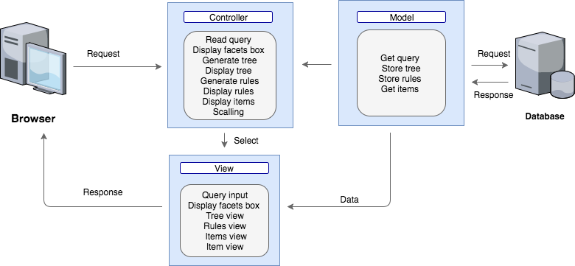

##### Figure 10. High level Architecture

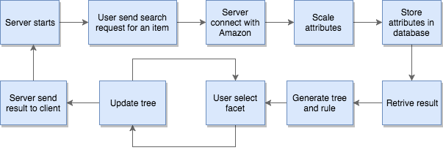

##### Figure 11. Project Flowchart

## Structural model

### Class Diagram

The detailed class diagram in **Appendix C *– Detailed class diagrams***

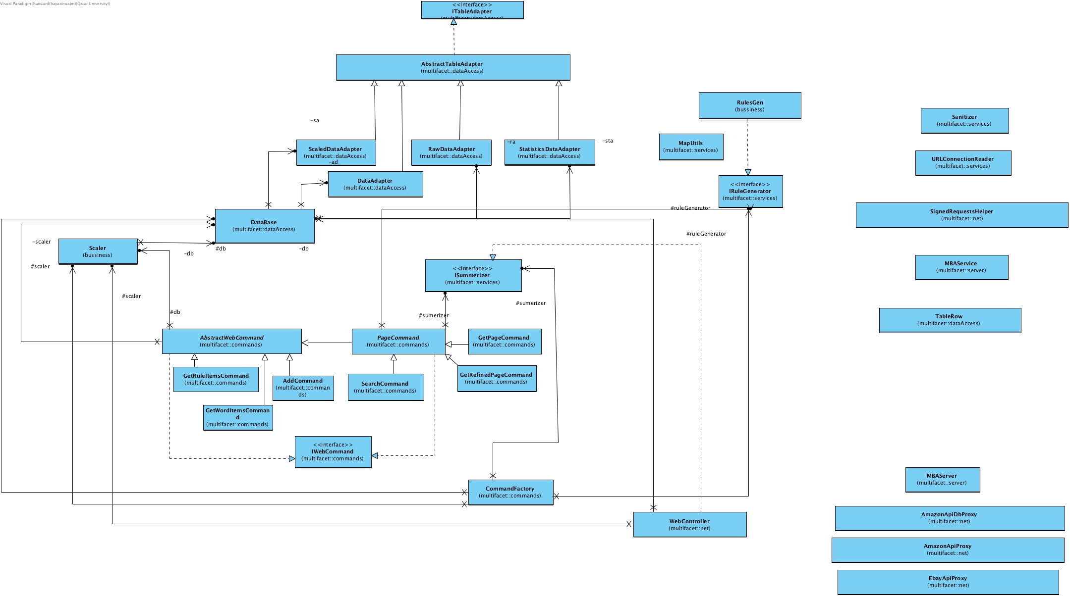

## Behavioral model

<ToDo:

You may break this section into subsections to document the behavioral model of each major module or use case.

The behavioral aspects of your software components could be documented using:

* Activity diagrams to describe the overall flow of control of your application (step-by-step workflows of components in your system).
* Design Sequence Diagrams (DSD) to document how to realize key use cases. Method calls in the DSD should be numbered and you show the parameters and the return type of each method.
* State diagrams for important parts of your system. You need to identify states and events that trigger state transitions.

/>

Sequence diagram:

1. Search for an item: when user type a word that he wants to search for, system will take this keyword and contact with providers to search for this word inside their database, if the keyword is not exist, system will display an error massage to the user, otherwise it will retrieve all items match with the keyword that the user enter and store it in the database, furthermore, facet box , tree and rules will be generated and displayed to the user

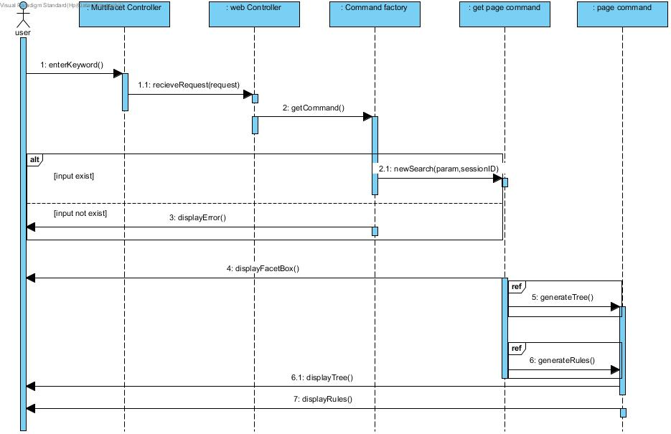

The activity diagram for search for an item shows the flow control of the system

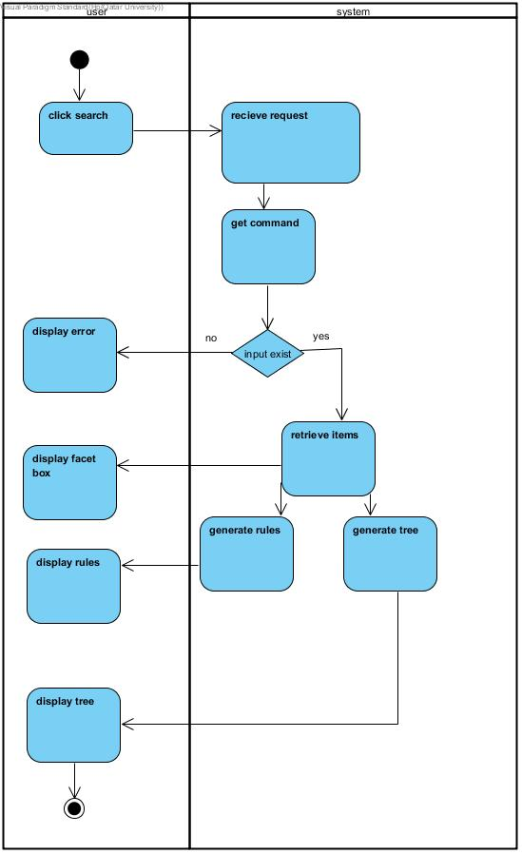

1. Select facet: user can select any values from the four facets that displayed in the facet box to refine his search result with, then tree will be updating to match the facets that the user decides to refine his search results by.

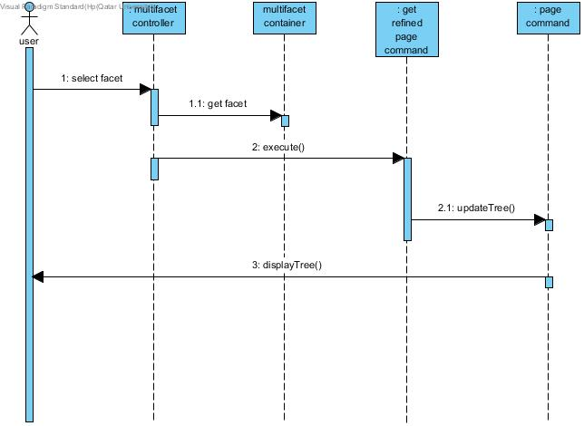

The diagram below represents the system activity diagram for select facet which shows the flow control of the system.

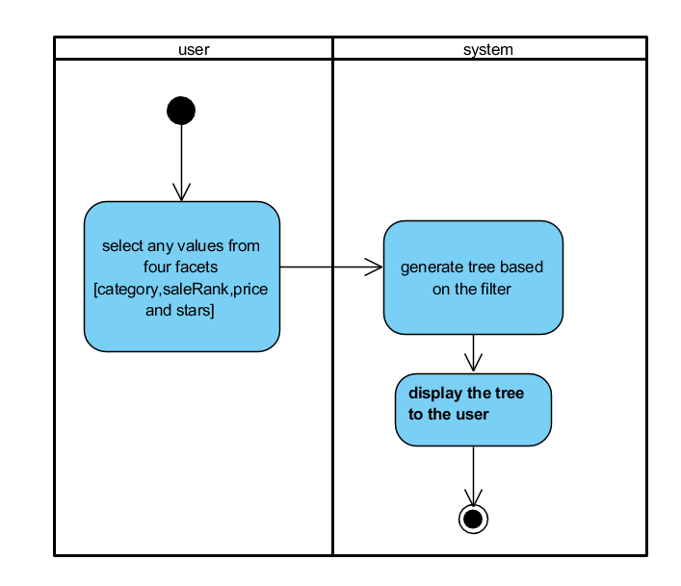

1. Generate tree: contact the database to get all items match with the search word, because tree will be generated by default by the search word that the user enters.

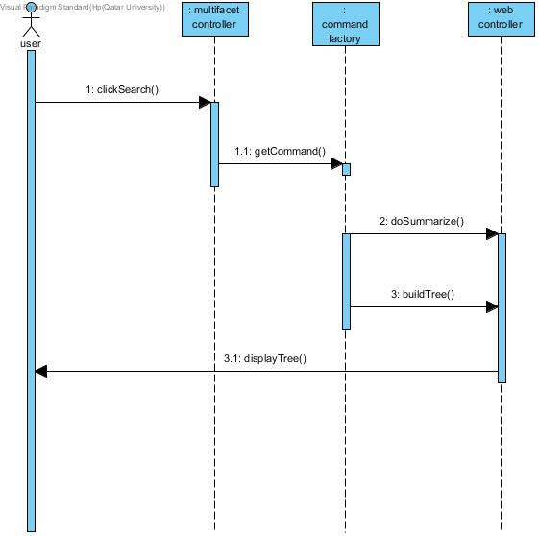

The activity diagram for generate tree shows the flow control of the system

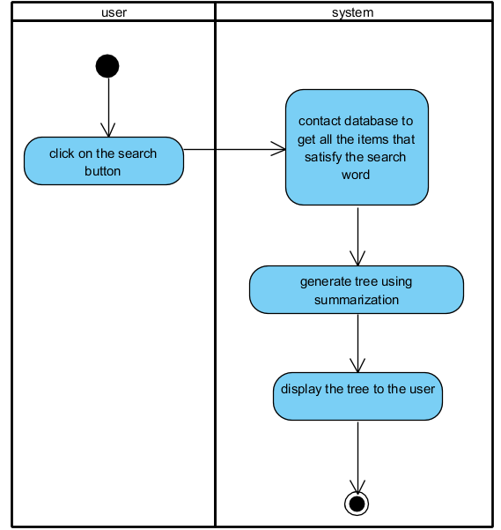

1. Generate rules: rules generated using Apriori algorithm, and display to the user the rules that have high confidence level.

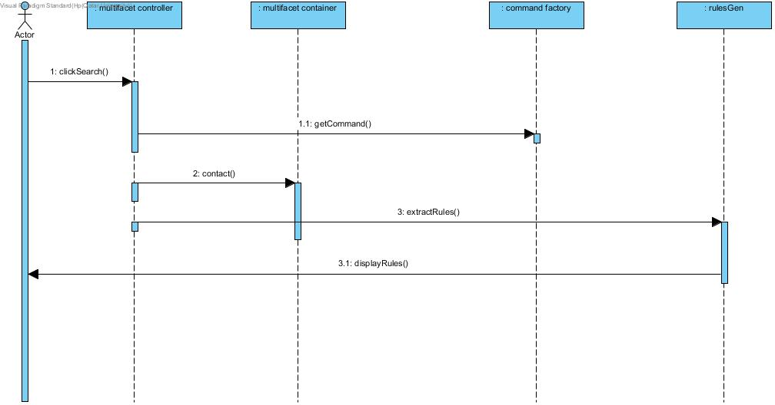

The activity diagram for generate rules shows the flow control of the system

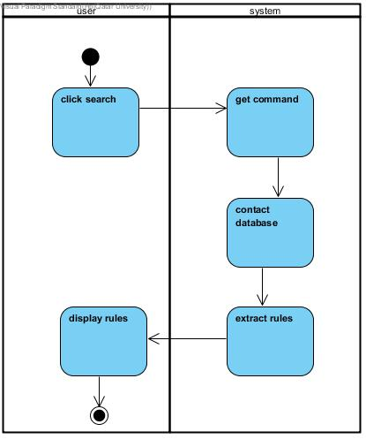

1. Display tree item/s: when user select specific node, system will check if its parent or leaf node. If the node is parent, all children of that node will be displayed to the user. If the item selected is a leaf node, display item will be called.

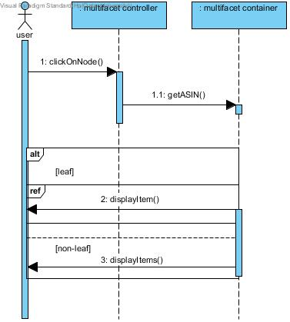

The process activity diagram for Display tree item/s:

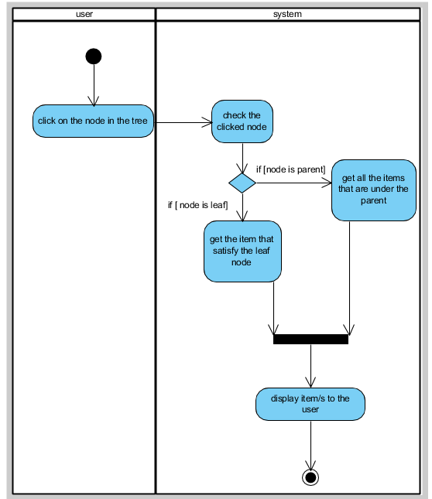

1. Display item: when user click on leaf item, system will contact database to get the link of that item, then route the user to this item in the provider page.

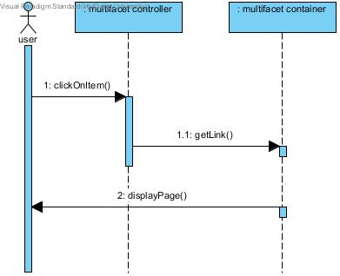

Activity diagram for Display item that show the process of the use case.

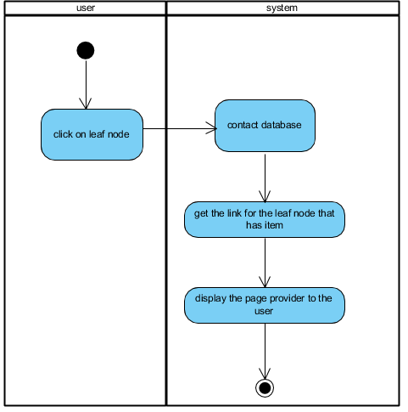

1. Display rule item: after generating rules, the user can select any rule, when he selects a rule, system will give the user all items that satisfy the selected rule.

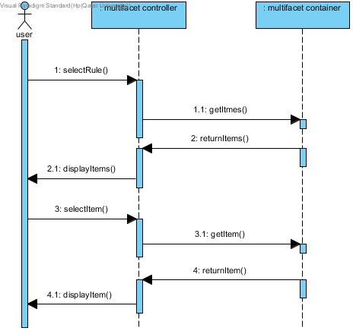

The diagram below shows the display item rule in activity diagram

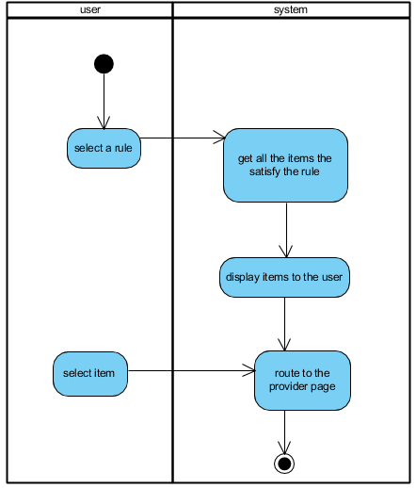

1. Update tree: tree will be updated, if the user changes the facets and click on filter.

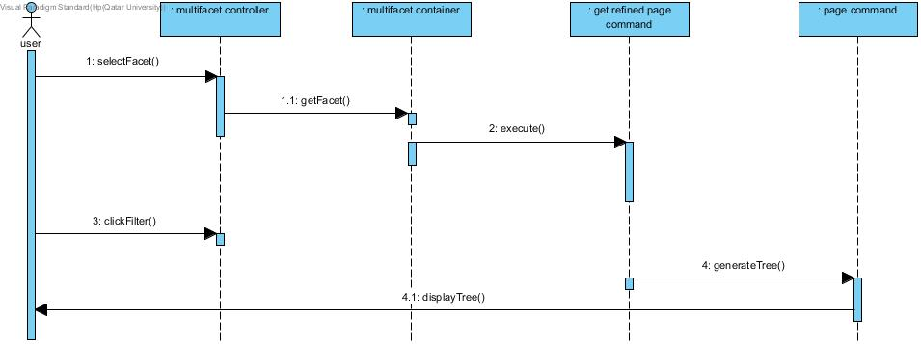

The activity diagram for update tree.

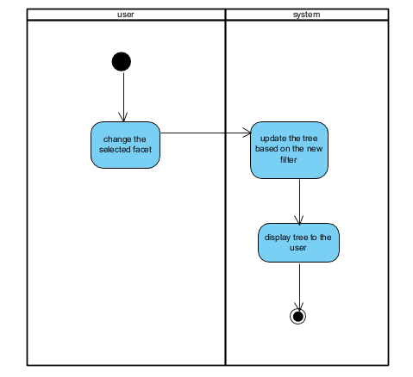

State diagram:

1. Search: user search, item will be retrieved, then extract the needed attributes and store them in a database. After that display facet box to the user, then generate tree and rules and display them to the user.

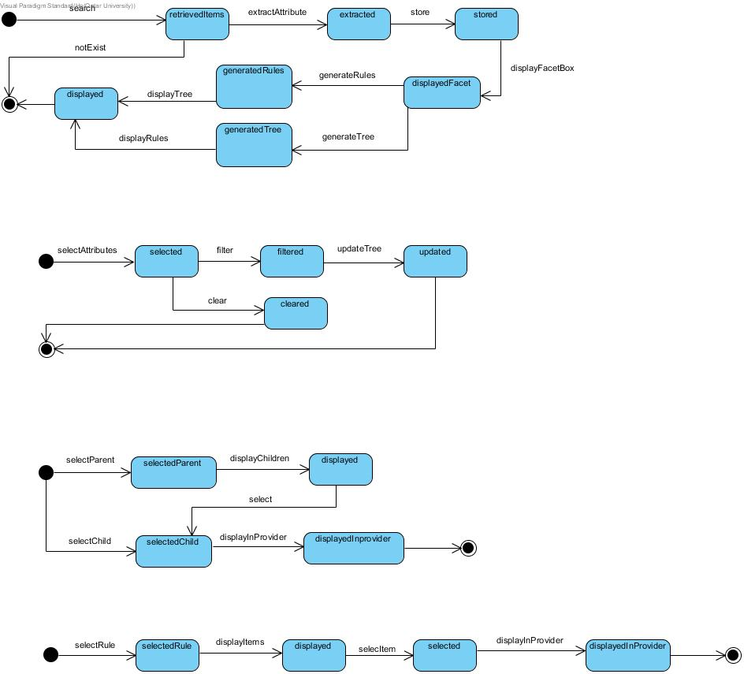

1. filter search result: after selecting the attributes either to filter the result with and tree will be updated based on the facets selected or user change his mind and decide to clear the facet that he selected.



1. select node from tree: when user select a node from the tree, it will be either parent node or leaf node. If its parent node, all children for that parent will be shown, otherwise if its leaf, it will be route user to the item in the provider page.



1. select rule: when rule selected, all items that satisfy this rule will be shown. After that if the user select item from displayed items, it will route him to the item in the provider page.



## Database design

Our application consists of three databases, Rowdata, Amazon-table and Stats. The Amazon-table database is holding all the attributes that coming from the provider starting by Amazon and in the next version of our system we add eBay as second provider, so we integrate the attributes that coming from eBay with Amazon attributes and add them in a single table. The schema for the Amazon-table database is shown in the (Figure ). The ASIN, requestID and pageId are the primary key which is a composite key. Where ASIN represent the item id and the request id to differentiate between search request, while the page id show which items in which page since each page present different items to the user.

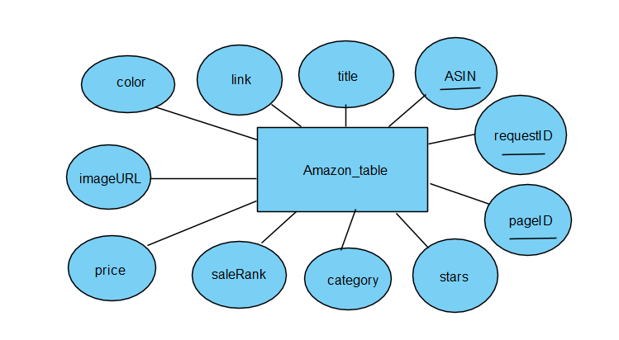

Figure-----: Amazon_table database schema

For the STATS database we have the following schema in Figure ----- . we created this table to evaluate our system performance in terms of the number of clicks and time. Also, we can use in the future to perform some studies to the time that the user takes to reach his/her desired item and the number of clicks that the user act to reach his aimed item.

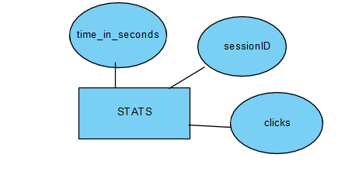

Figure-----: STATS database schema

Furthermore, we faced a problem with Amzon API and we had to create another database which is RowData. It consists of historical data from Amazon instead of dealing with Amazon API itself. The attribute is similar to Amazon-table since we are storing the same data. The schema for the RawData database is shown in the (Figure ----).

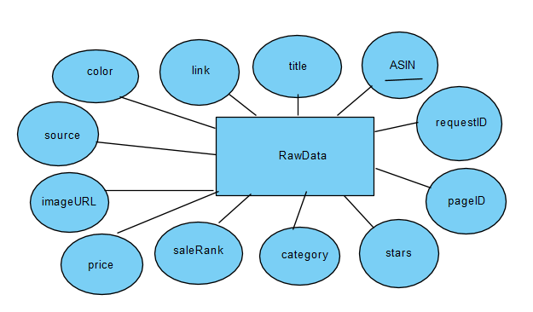

7Figure-----: RawData database schema

## User interface design

We choose an architecture that will offer our application a simple interface with a strong operational core. Hence we proposed to use these interfaces shown in Figure 12, for the diverse activities our application will have in company with how would the client explore them. The web application we are going to develop will have a multi-facets filtering. The initial concern is to narrow the search query in a way that will structure in a tree consequently the user can easily browse the results.

[read again]

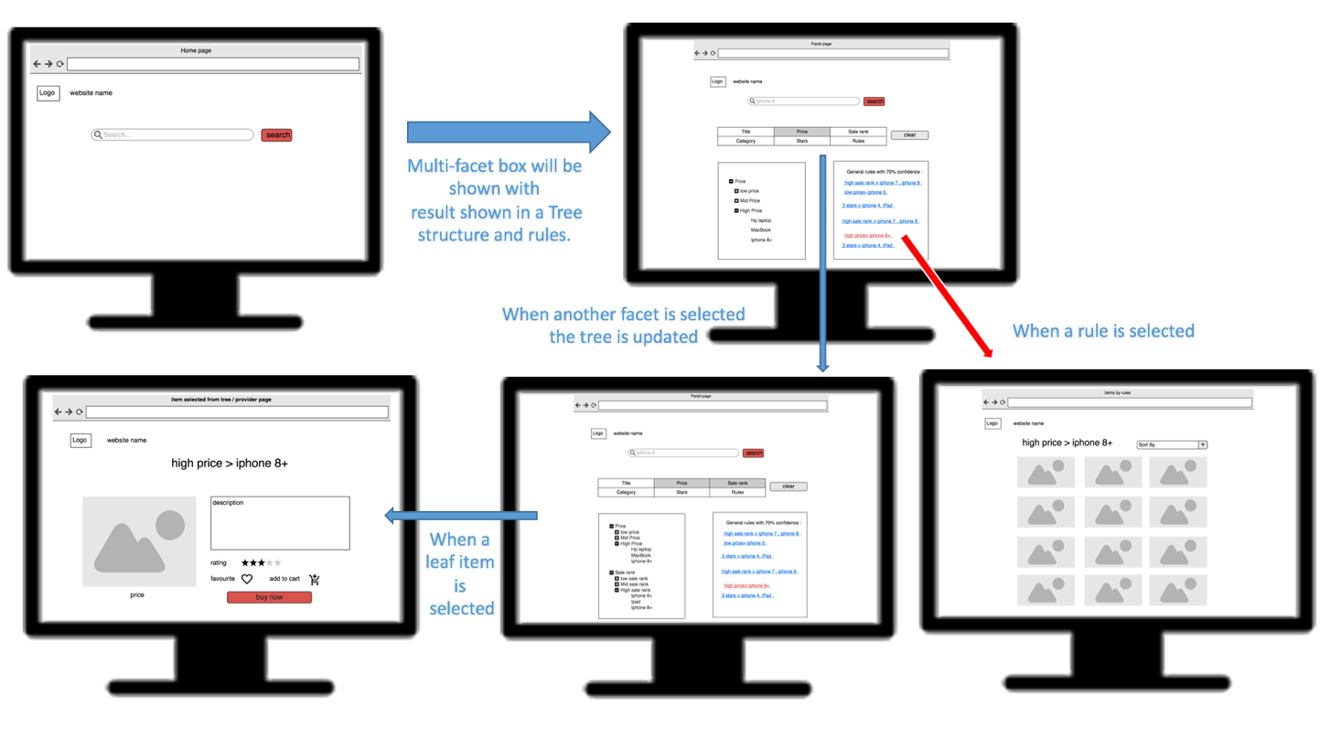

##### Figure 12. Interface design

## Design patterns

### Structural design patterns

1. **Proxy Pattern**

In terms of structural patterns, we use Proxy Pattern since the access to an object should be controlled. We are applying this pattern to the classes responsible for requesting items from the provider either by API or from Database. This pattern provides the protection to the original object from the outside world. So, we can perform many operations like hiding the personal information in the API keys of original object. In our project, we made proxy for the “AmazonApiProxy”, “AmazonApiDbProxy” and “EbayApiProxy” classes; where we call in each new search command.

1. **Adapter Pattern**

We used the Adapter pattern to bridge between two incompatible interfaces. This pattern involves a single class which is responsible to join functionalities of independent or incompatible interfaces. We have applied this design pattern in dealing with different tables in the database. Where each table has its own adapter “ScaledDataAdapter”, “DataAdapter”, “RawDataAdapter” and “StatisticsDataAdapter” extends “AbstractTableAdapter” and it implements the interface “ITableAdapter”.

### Behavior design patterns

**Command Pattern**

### Creational design patterns

1. **Factory Pattern**

Our web application deals with many commands since each command is responsible of a functionality. Using factory pattern makes our application a reusable object-oriented software; since it relies on inheritance, as object design is given to subclasses that implement the factory method to create objects. Another benefit of using factory pattern is that it is more customizable and only a slight more complex comparing with other patterns. The other design patterns need new classes, whereas Factory Method only need a new operation. This design pattern is applied for the “CommandFactory” class in our application.

1. **Singleton**

The idea of having a singleton pattern applied is to control the instances. For example, if you make the constructor private, you cannot do a new to create a new instance. Hence, you are controlling the creation of the instances. This design pattern is applied for the “DataBase”,” SignedRequestsHelper” and in “Scaler” class. To allow one instance of each we declared the constructor to be private and added a getInstance() function that make sure that we have one instance of each class. By applying this pattern, we achieve two main quality attributes: Performance and scalability. Since we allow only instantiation of one version of each class, this decrease the complexity of the project and thus the performance increase. It also allows to project to grow since we don’t need to apply a huge modification. It will be only needed for the single object.

## Hardware/software to be used

1. **Hardware:**

Table 10: Hardware

|  |  |  |
| --- | --- | --- |
| **Device** | **Operating System** | **Justification** |
| **MacBook.** | Mac OS Sierra (OS X 10.11). | To build the application. |
| **HP Pavilion** | Windows 10. |

1. **Software:**

Table 11: Software

|  |  |  |
| --- | --- | --- |
| **Category** | **Tools** | **Justification** |
| **Graphics** | Adobe Photoshop – moqups  draw.io | To design the web application’s interface, pages, logo, mockup and layout. |
| **Development of source code** | Eclipse  Webstorm | Eclipse: For implementing of the code.  Webstorm: To implement the web application. |
| **Java Libraries** | Weka | For extracting the Association rules. |
| **Database development** | SQLite Studio | For databases usage. |
| **Programming languages** | Java  JavaScript, HTML and CSS | Programming language used to develop our application.  To implement the web application, we will use JavaScript, HTML and CSS. |
| **Modeling** | Visual Paradigm for Unified Modeling Language (UML) diagrams. | To model the project as class diagram, sequence diagram etc. … |
| **Documentation** | Microsoft Office:(Microsoft PowerPoint – Microsoft Word ). | To document every step in the project with references. Additionally, to create the project’s presentation, report. |
| **Code Transfer** | GitHub Desktop | Code collaboration and synchronization |

# Implementation

The proposed application is called “MOSS”. It stands for Multifacet Online Shopping System. The icon is simply a tree with a trolley in the shape of letter ‘e’ at the roots indicating electronic shopping, additionally the letter ‘R’ indicate the rules that our system will provide to the user. MOSS size is 4.17 MB. The web application was built with different versions; each version included improvement in performance, extra features and functionalities.

## Version 1

The web application gets a query from the user and retrieves results from provider for that query. Then the data will be extracted and saved in database. After that we applied Porter stemmer to stem the titles and then build the tree based on the stems of each item title, as shown in Fig##. The generated conceptual tree represents the concepts in a heap data structure. User can navigate through the tree and when selecting the leaf node, it will rout the user to the item page in the provider site. Additionally, user can select one or more facets to filter the try by. In terms of data discretization, we divided the data into ranges based on certain formulas mentioned above ($$$) to build a formal context. We applied Apriori algorithm using Weka library in Java to extract association rules from 0-1 context.

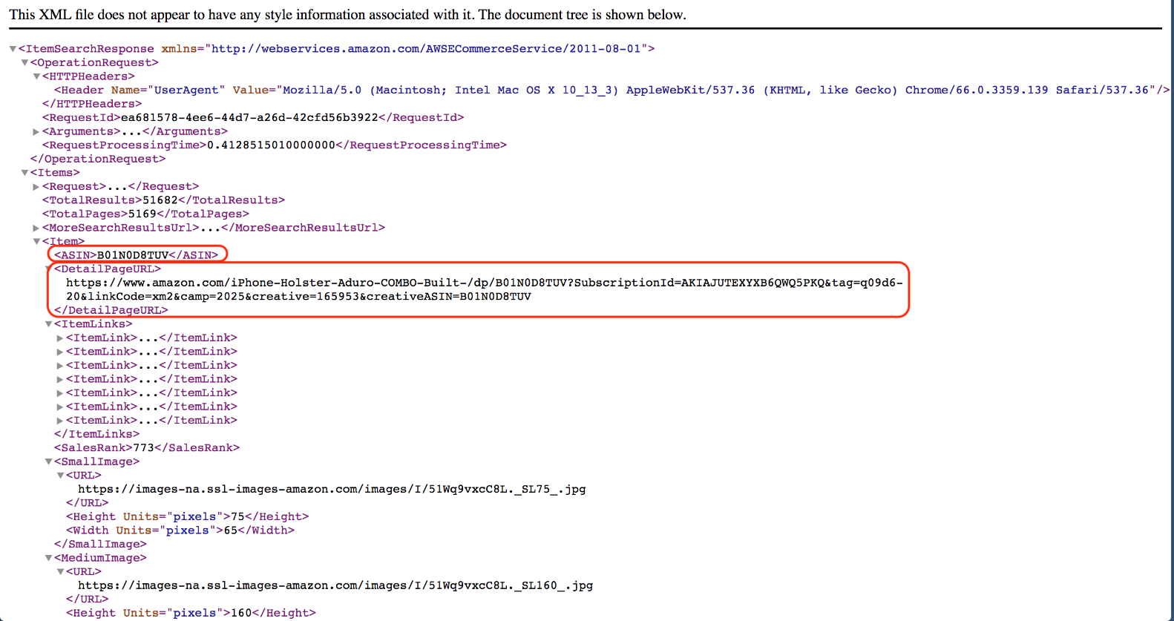

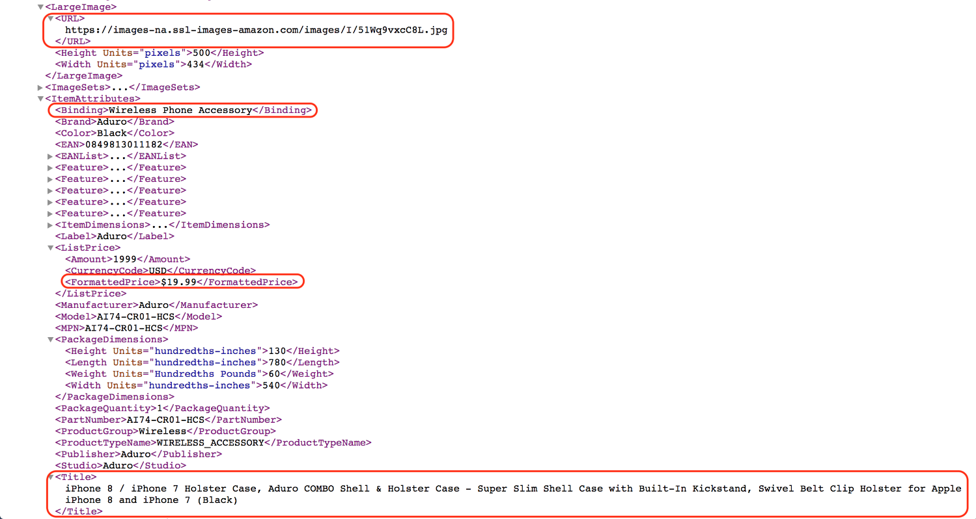

Figure : XML retrieved from the Amazon API

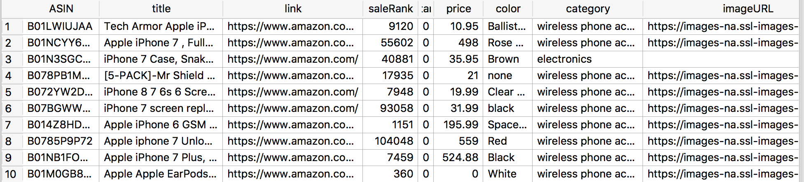

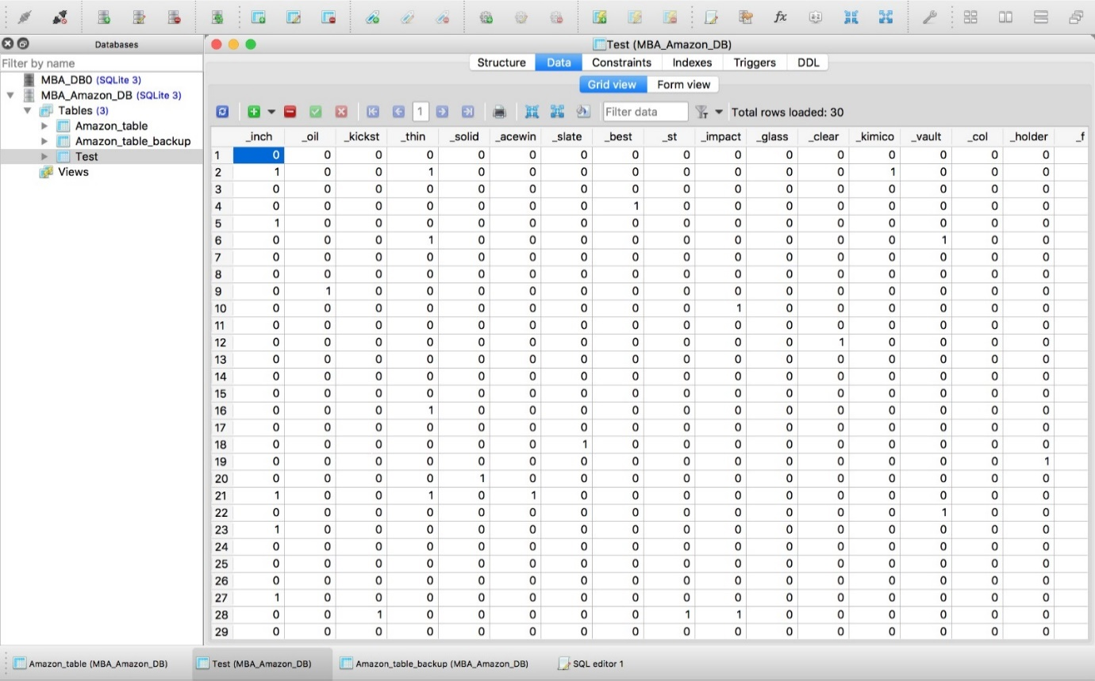

**Tree of concepts**

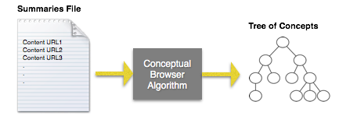

Figure : Illustration of creating the conceptual tree based on stems

## Version 2

The application is modified in terms of tree where we generate the tree based on summarization instead of steaming. Since the summarization code gives us the result using understandable words to the user. In terms of features we added two important buttons to the user; which are next and previous buttons; that enable the user to navigate through different pages. Where in the next page the generation of rules and tree are incremental since the next set of items will be added to the context and then the generation will be based on the whole context. As more as the user route to the next page the rules become more accurate.

Table 3: Comparison between query time and next page retrieval

|  |  |  |  |  |
| --- | --- | --- | --- | --- |
| Query | Time to get first page (seconds) | Time to get second page (seconds) | Time to get third page (seconds) | Time to get fourth page (seconds) |
| Iphone 7 | 21.34 | 18.78 | 16.525 | 14.542 |
| Hp printer | 22.384 | 19.697 | 17.334 | 15.2545 |
| Canon camera | 19.97 | 17.573 | 15.464 | 13.6089 |
| Samsung Galaxy | 23.02 | 20.257 | 17.826 | 15.687 |
| Total running time | 21.6785 | 19.07675 | 16.78725 | 14.7731 |

Add screen shoots of tree (stemmed-summarized)

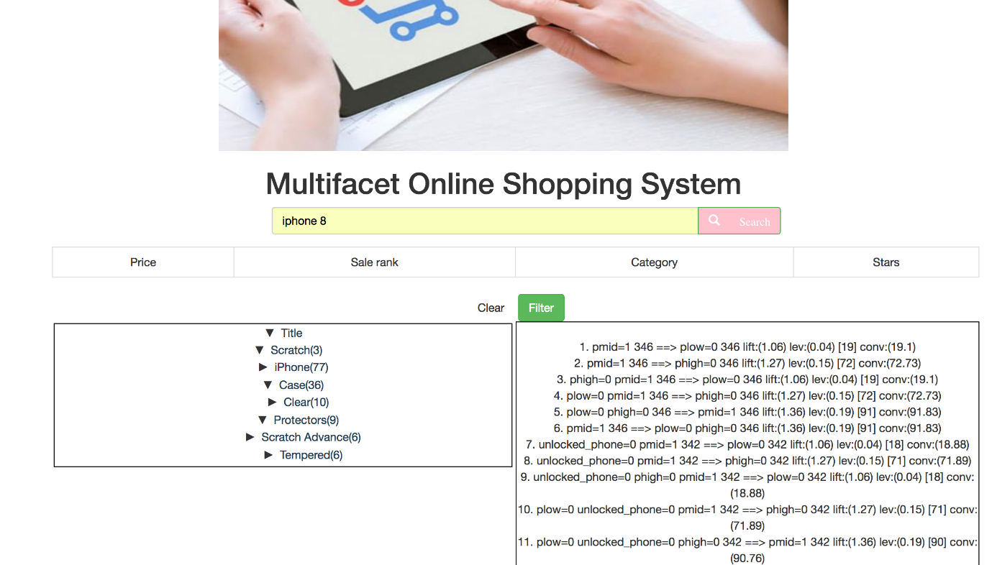

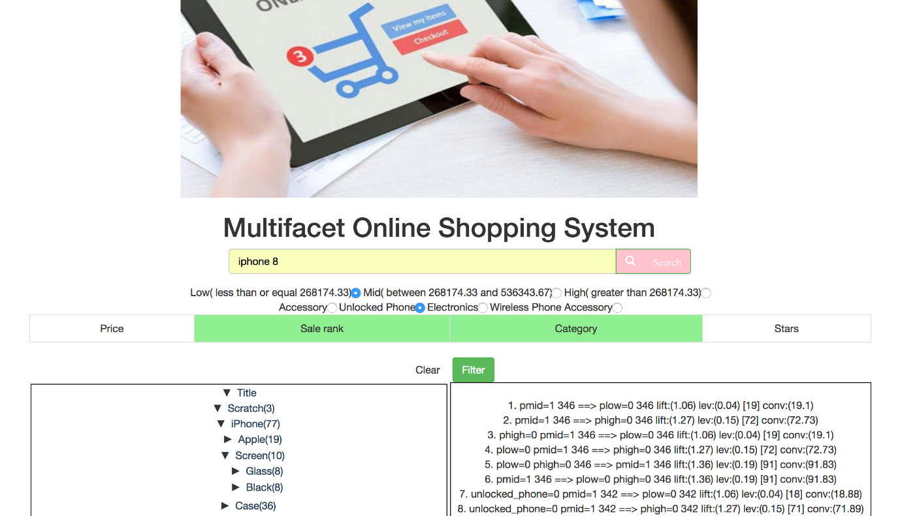

Figure : Screenshots of the application developed version 2

Version 3

In this version, we encountered problems regarding the association rules that appears to the user. Which are having rules associating discretized attributes from the same attribute itself for example, when the Apriori algorithm mined the context and found that (pmid=1=> plow=0) , as shown in Fig##.



Figure : Rules generated from 0-1 context

It is defiantly an association rule, but it does not give any benefit to the user. On the other hand, it is also finding all relations where we are interested on the occurrence of the discretized attributes not when they are not applicable. In result, we updated the discretization of attributes to have the value itself instead of 0-1, as shown in Fig##.

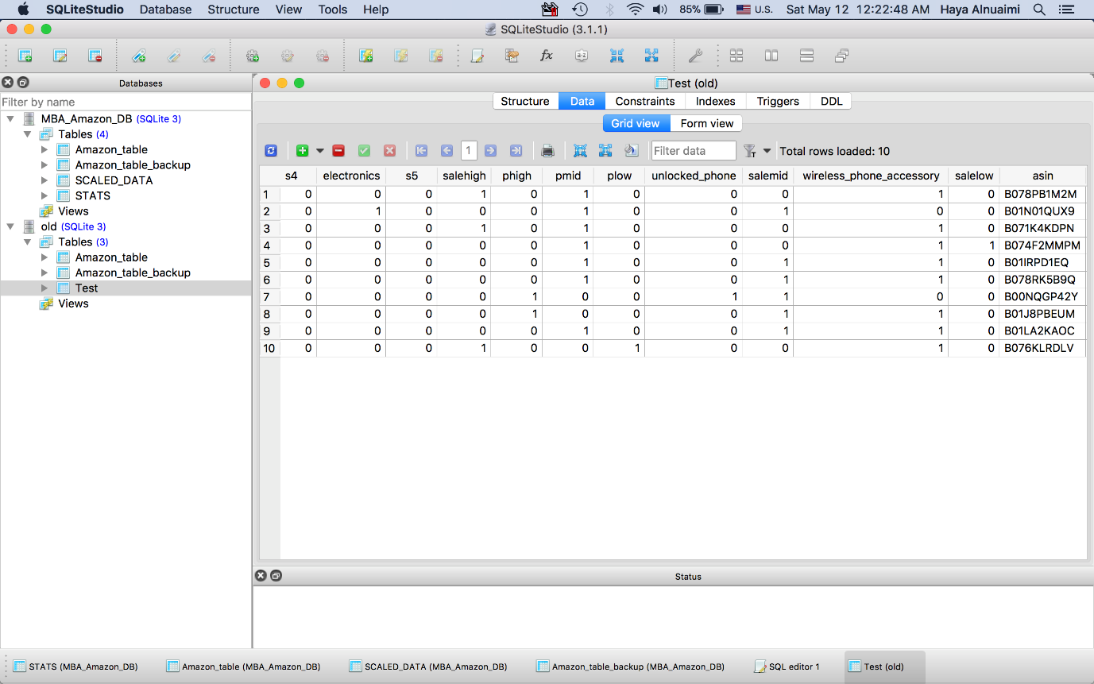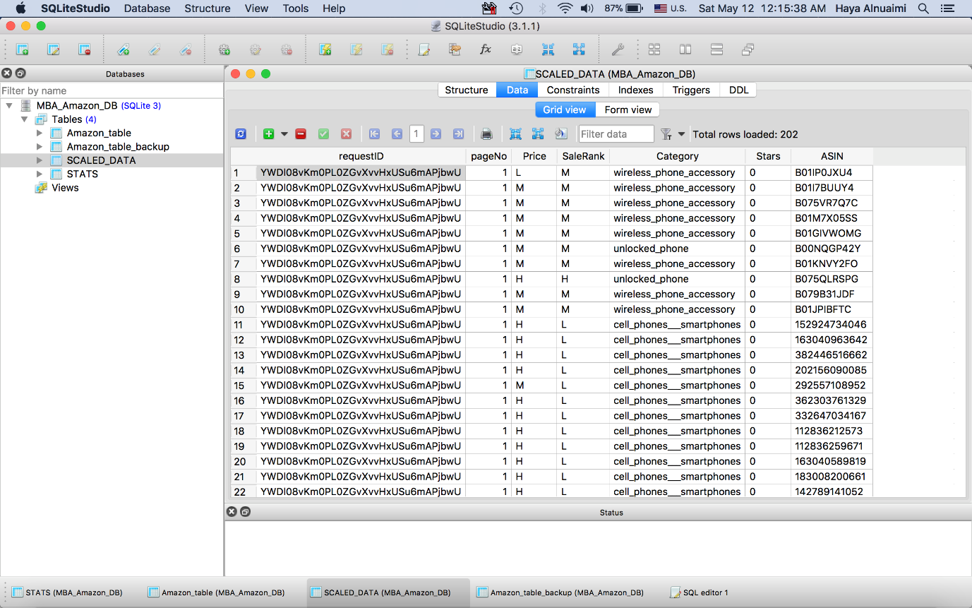

Additionally, we are aiming to decrease the number of clicks of the user, so we showed the tree already expanded to enhance the performance. Moreover, we added another provider which is eBay, and integrated its data into the same context. Since there are less number of common attributes we decided to read only two attributes which are price and category. After trials, to enhance the performance we balanced the number of retrieved items from both providers with more acceptable amount of time.

Table 3: Comparison between query time and the number of items retrieved

|  |  |  |  |
| --- | --- | --- | --- |
| Query | Time to retrieved 50 items (seconds) | Time to retrieved 30 items (seconds) | Time to retrieved 20 items (seconds) |
| Iphone 7 | 7.452 | 5.9616 | 4.5904 |
| Hp printer | 9.329 | 7.4632 | 5.7466 |
| Canon camera | 8.265 | 6.612 | 5.0913 |
| Samsung Galaxy | 9.23 | 7.384 | 5.685 |
| Total running time | 8.569 | 6.8552 | 5.278325 |

Graph : Comparison between query time and the number of items retrieved

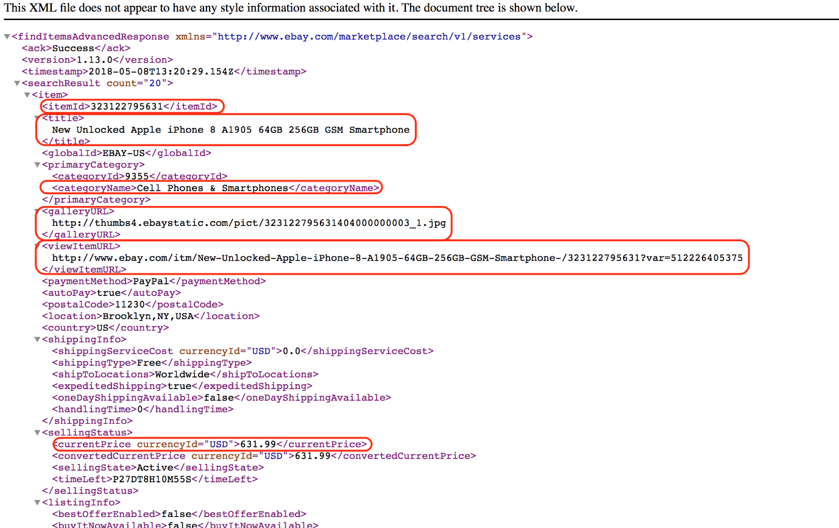

Figure : XML retrieved from the eBay API

Figure : XML retrieved from the new eBay API

## Version 4

This version was developed in order to enhance the system performance. In order to achieve that, threads were used to speed up the retrieval of data from providers, where each thread retrieve from a specific provider. Figure ## shows the difference between the last version that does not use thread and the new version with parallel execution. In order to test it, some test queries where issued with the older version and the new version of the app. Table ## shows a comparison between the new version and the old one, it has the queries and their execution time. The table also displays the average response time of the system. Without threads it takes about 21.7 seconds, and with threads it takes 12.3 seconds. Therefore, the system is enhanced by 9.4 seconds. On top of that we are

Table 3: Comparison between query time before and after parallel execution

|  |  |  |  |
| --- | --- | --- | --- |
| Query | Time without threads (seconds) | Time with threads (seconds) | Average improvement time (seconds) |
| Iphone 7 | **21.34** | **13.04** | **8.3** |
| Hp printer | **22.384** | 12.9 | **9.484** |
| Canon camera | **19.97** | 12.28 | **7.69** |
| Samsung Galaxy | **23.02** | 10.87 | **12.15** |
| Total running time | **21.6785** | 12.2725 | **9.406** |

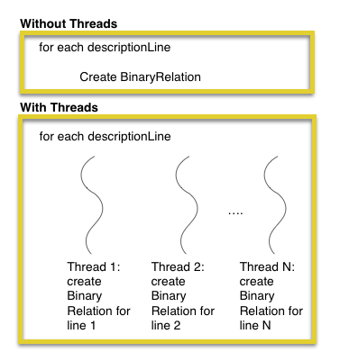

Figure : Comparison Between Older and Newer Version After Using Threads

## Version 5

The next version included some functionality that will enhance the users shopping experience. In the past versions the user had to navigate his way in the tree to reach the leaf node then it will rout him to the items page. In order to enhance the experience, we added a functionality where every node will contain URLs that satisfy the concept. So when after building the tree, and the user click on a node with a keyword, the list of URLs is built at that point. It will request from the database all items URLs that has the keyword of the node in its title. Additionally, we have added some messages which can help the user understand our interface more.

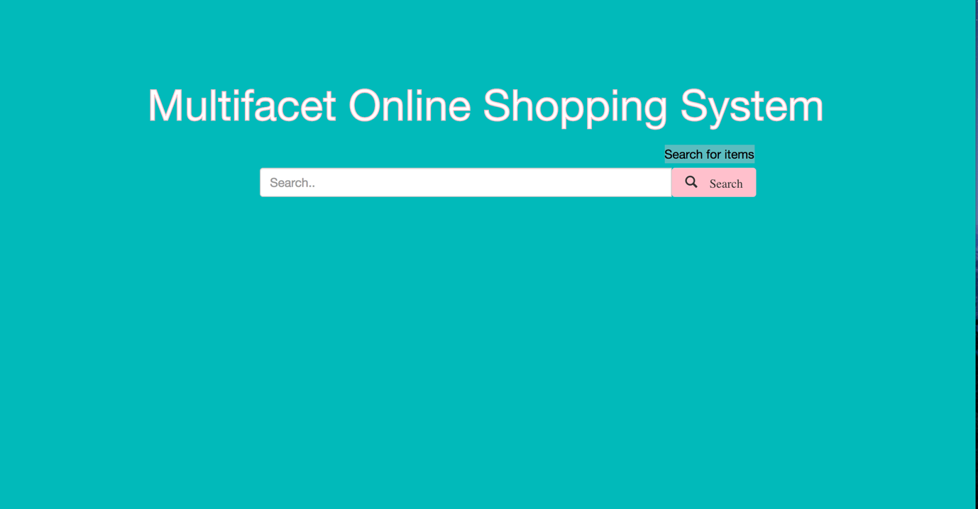

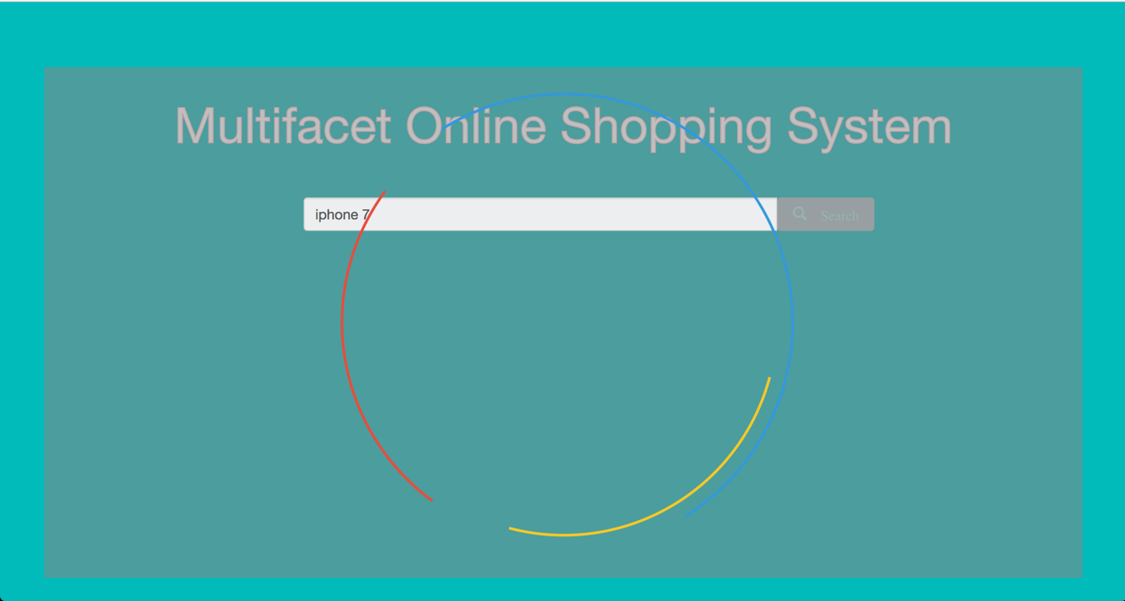

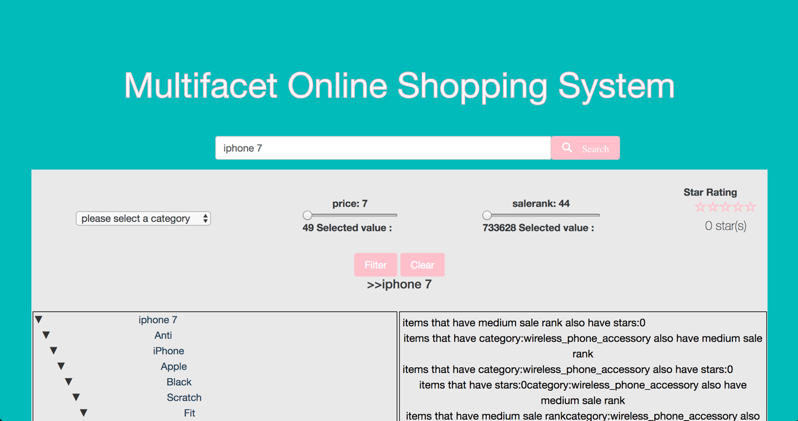

Figure#: the interface of our web application

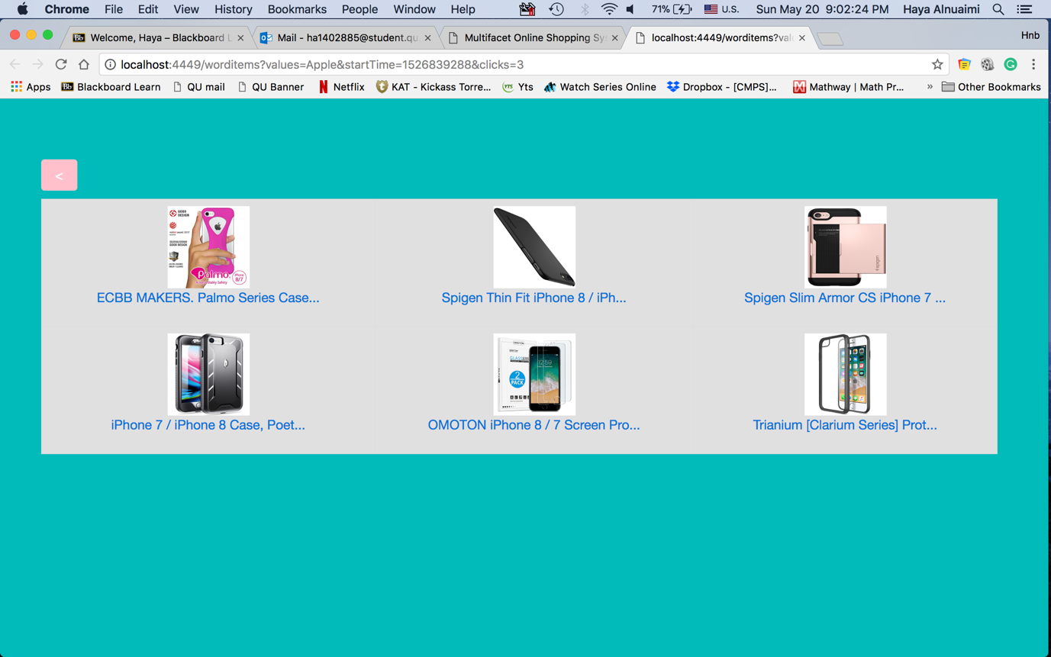

Figure#: When clicking on a parent node items with its value will be shown

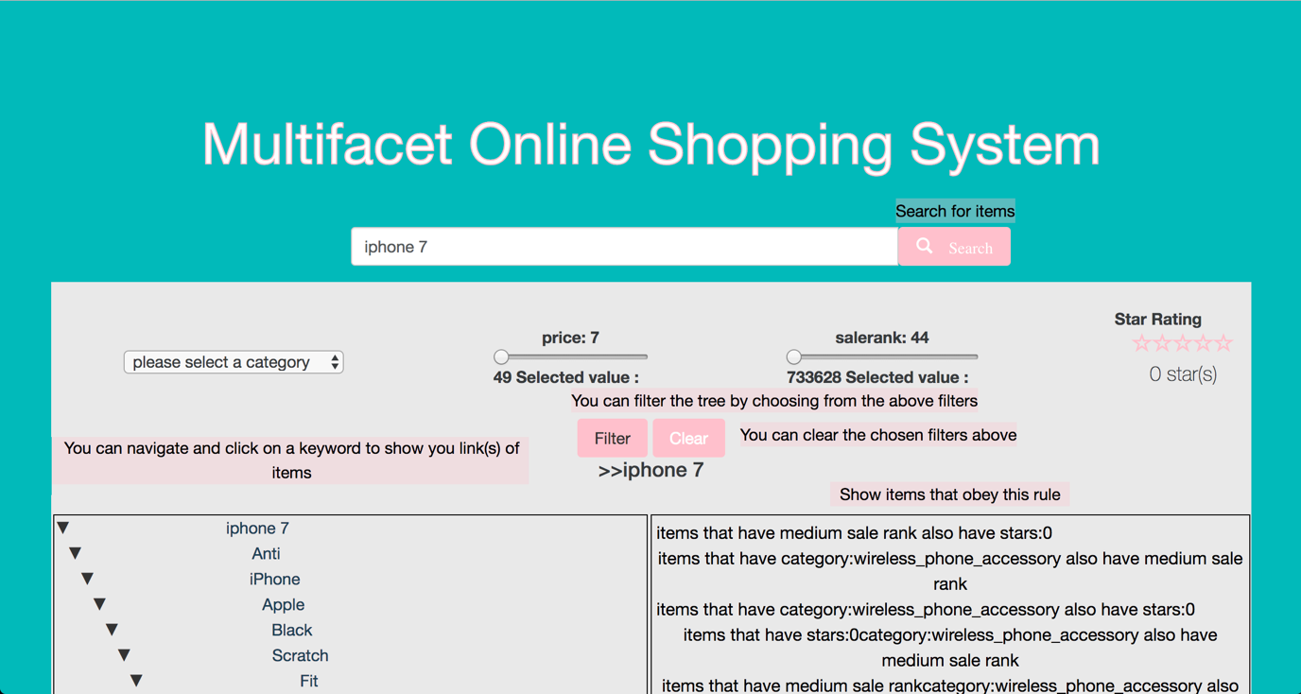

Figure#: Messages shown to help guide the user

## Version 6

The last version included some unexpected turns, where Amazon blocked our API Advertising services due to changing in there policy, as shown in Fig(##). We tried to solve this issue but many obstacles where in our way, for instance in the identity verification step they require a phone number but for a reason we don’t know all Qatari phone numbers are blocked, as shown in Fig(##), and if we use an American phone number they require an interview and tax papers. Moreover, we tried Egypt phone number and tax papers where required. So we came up with a temporary solution where we can use all the data that we retrieved during our testing process of the system and crawl Amazon to have a fraction of Amazon database where we can continue using for the testing phase. We created a database filled with all historical data and with each new request instead of contacting Amazon API we will contact the database.

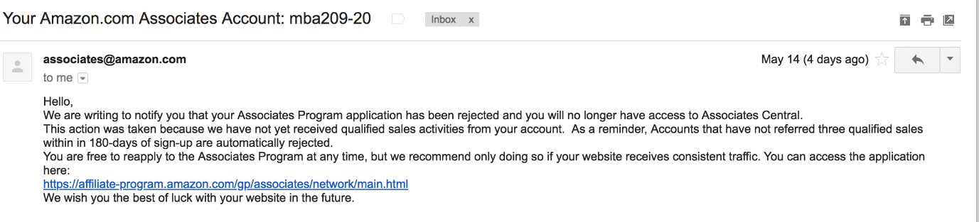

Figure#: Email from Amazon

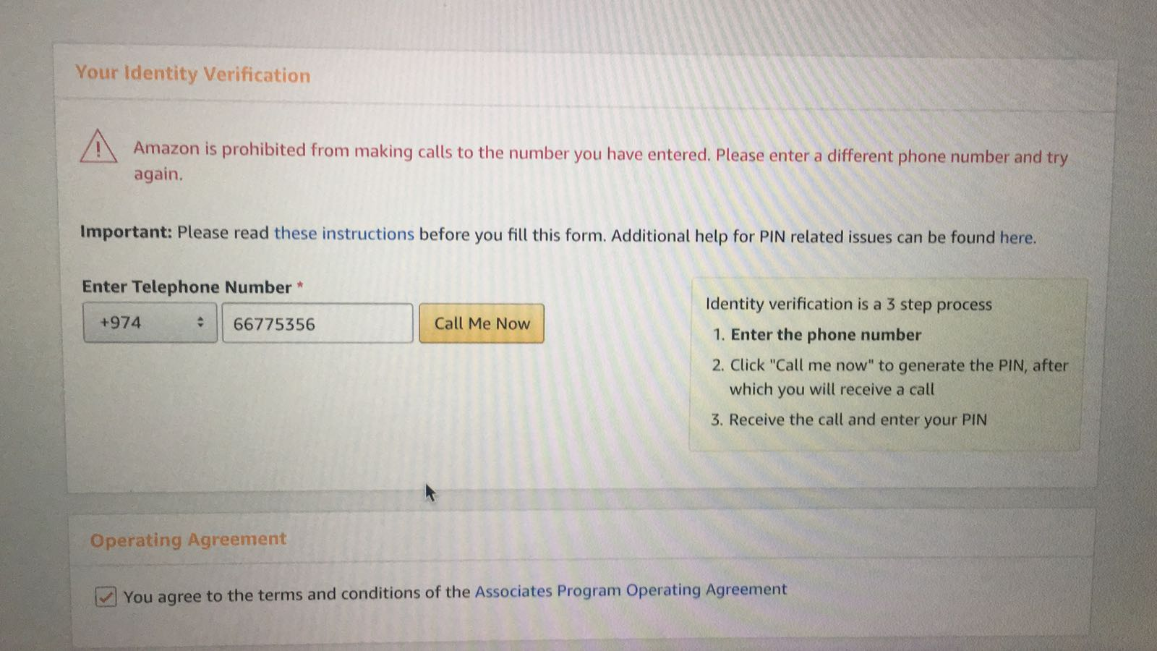

Figure#: Amazon blocking Qatari phone numbers

# Performance Improvements

In order to achieve an acceptable response time, we needed to reduce the processing time as much as possible. One of the improvements is limiting the tree nodes. This will help by reducing the time needed to find the optimal concept from the retrieved items. Second improvement is limiting the number of items retrieved at a time. We retrieve 10 items from every provider at a time, and the user can get more result by clicking the Next button. However, reducing the items at a time will reduce the time in building conceptual browser tree. Since the speed is prioritized here, we trade off the number of items retrieved at one request. Last enhancement is related to the multiple providers. In order to increase the speed of the performance, we need to do things in parallel, so we used the threads.

# Testing

<ToDo:

In this section you should **describe in detail the tests** you have conducted to verify that your prototype satisfies the desired functional and non-functional requirements. The testing should verify and provide evidence that your solution solved the stated problem and satisfied the requirement specifications (if not explain what is lacking).

* Describe in detail the tests you have run to verify that your prototype satisfies the functional requirements of your project. For example, if you used Use Cases to describe your non-functional requirements, then for each use case you should write a test case, run it and report the testing results (the key test cases can be added as an Appendix). Functional testing will allow you to find defects then fix them and also identify possible improvements. You need to have a comprehensive set of tests that verifies correct functionality of every component of your system.
* Describe in detail the tests (e.g., performance testing, usability testing, etc.) you have run to verify that your prototype satisfies the non-functional requirements of your project. Include a summary table that shows each non-functional requirement and the measurements that prove your system met/did-not-meet the requirement. In case a requirement is not met, then explain the reason for that.

You should **present the test results**, with appropriate level of details in addition to accuracy and completeness**,** using tables, graphs, diagrams, screen shots etc. Additionally, **discuss these results** and explain whether the prototype has achieved the requirements. If not state what is lacking or still need improvement then explain the reason for that. There will probably be multiple subsections under this section to describe each system test and its result.

Note that this section is a substantial portion of the grade for your final report, and will require a significant amount of effort.

/>

# Expected Impact

**Impact on individuals**

Our web application will have an impact on individuals since it is easy to use and is understandable by users. People nowadays know how to use online websites; this fact will increase the opportunity of using our application very frequently. The main reason why they will decide to use our application is that the interface is very user friendly and reduces the time spent on acquiring their desired item. ­­­ Also, all people search for a site that has variety. For instance, one can get numerous brands and products from different sellers at one place. In addition, individuals are likely to shop about specific items that they want to buy from different providers and so, our application will provide a multi-facet feature and integrate multiple websites in one application. Hence, they are likely to use our site instead of browsing in more than one online shopping site and wasting valuable time. There is also a section of people, who are considered a part of our main targeted user-base, we believe that this application will help, and those are sellers. That is because they relay on many people buying their products on online websites due to some of them not having physical shops.

**Impact on society**

The multi-facet feature of our application will be one of the main reasons that causes people to use it, since they find it more convenient and easier to find an item quickly from different providers. It will increase the awareness of shopping due to the fact that it is portable and can be used on many platforms, including phones and laptops. Therefore, it will have a large positive impact on the society such as increasing the sellers’ income. In addition, our application supports only the English language because it is the lingua-franca of the globe, and most people are familiar with it. Therefore, people in different countries can benefit from our application and use the tree feature and rules to get their desired item. Another impact of our application on society is enabling people to improve their shopping experience.

# Conclusion

< ToDo:

* Discuss the main conclusions (e.g., match the project objectives with the achievements in your work and state the degree of achievement).
* Highlight the strengths of the solution and list down its shortcomings (what worked? what didn’t work?).
* Highlight the key contributions and the novel aspects of your work.

/>

# Future work

Currently we are satisfied of our application, taking into consideration the amount of time we spent on developing it. However, it still needs some improvements in terms of performance, specifically the time needed to build the conceptual tree for the user, to be within 1-3 seconds. Furthermore, to target much more users than the current users, we are aiming to extend the scope of our system by including more providers. Also, developing a mobile version of our system in android and IOS. In addition, adding more features like voice recognition, where the application accepts voice queries as well as the typed, this will give opportunity for special needs to use our system. Moreover, accept searching by photo either by taking image or by choosing image from gallery.

Add in future work: Restoring and cashing that data in every session and also validate the system

# Student reflections

< ToDo:

Add individual student **reflections** (**add a sub-section for each student**):

* Lessons learned from the project.
* Professional development you have achieved during your project experience (i.e., new skills gained) and explain its value for your future career.

You can discuss (1) new technical skills acquired such as solving problems, designing and realizing solutions (2) interpersonal skills such as team leading and effective communication (3) personal growth such as adapting to change and acting professionally and ethically.

* Key shortcomings that you should avoid in future projects.
* Key lessons and new attitudes to carry forwards to your professional life from the personal experiences and the team work experienced during the project.

/>

# Appendix A – Project Plan

## Project milestones

###### Table 12. Milestone Fall 2017

|  |  |  |  |
| --- | --- | --- | --- |
| Milestone | No. | Tasks | Description |
| M1:  Understand the project idea | T1 | Determine the problem | Identify the project problem. |
| T2 | Identify objectives | Identify the purpose of the project. |
| T3 | Project abstract | Write a short paragraph explaining the project. |
| T4 | Project background | Write some paragraphs about the project background. |
| M2:  Related Work | T5 | Read and search for related work | Read and search for work done before in the same field of our project. |
| M3:  Requirements Analysis | T6 | Use-case diagram | Determine our system use cases. |
| T7 | Use-case specifications | Provide the use-case specification for each use-case. |
| T8 | Write the non-functional requirements | Identify the non-functional requirements for the system. |
| T9 | Write Code of Ethics | Identify responsibilities relevant to our project. |
| T10 | Identify assumptions | List our project assumptions. |
| M4:  Proposed Solution | T11 | Solution overview | Provide all possible solutions for all stages of our system. |
| T12 | Selected solution | Discuss appropriate solutions for our system. |
| T13 | High level architecture | Choose a suitable architecture and describe each component. |
| T14 | Hard & Software used to be used | Classify and list all the hardware and software that will be used in this system. |
| M5:  Extracting data | T15 | Learn about hidden data | Discover ways to find hidden data. |
| T16 | Explore ways to extract data | Search and read about ways to retrieve data from online shopping systems. |
| T17 | Extract data using APIs through a java code | Write a code using APIs to extract hidden data. |
| T18 | Store data in a database | Store data using SQLite  [SQLite is an embedded SQL database engine] |
| T19 | Scaling data | Convert the extracted data into 0’s and 1’s matrix. |
| M6:  Explore and study algorithms | T20 | Learn about different algorithms | Search and explore different algorithms that can be used and was used in the same field. |
| M7:  Project Plan | T21 | List project milestones and timeline | Identify project milestones and break them into tasks. Then, create the timeline. |
| T22 | Write anticipated risks | Write some assumptions about expected risks during implementation. |
| M8:  Implementation | T23 | Design mock interface | Design a mock interface and provide the life cycle for the system. |
| T24 | Draw a flowchart | Draw a flowchart to illustrate all phases of the project. |
| M9:  Report finalizing | T25 | Finalize the report | Proofread the report and check all parts. |

###### Table 13. Milestone Spring 2018

|  |  |  |  |
| --- | --- | --- | --- |
| Milestone | No. | Tasks | Description |
| **M1: System design** | T1 | Class diagram | Create structural model for our system. |
| T2 | Sequence diagrams | Using sequence diagrams for each use-case we will determine the system’s behavioral model. |
| T3 | Activity diagram | Another diagram to determine the system behavior. |
| T4 | State diagram | Identify the system states. |
| T5 | Database design | Describe the entities and the relationship between them. |
| T6 | Design pattern | Distinguish the design patterns applied to our design. |
| **M2:**  **Implementation** | T7 | Implement classes | Implement all classes in the class diagram. |
| T8 | Implement functions | Implement functions in the class diagram. |
| T9 | List tools | List all the tools used for implementation. |
| T10 | Identify challenges | List challenges met while implementing. |
| **M3:**  **Testing** | T11 | Testing | Test each milestone since we are using spiral model. |
| **M4:**  **Finalizing** | T12 | Expected impact | Determine the social impact of our solution on individuals and society. |
| T13 | Conclusion | Write a short paragraph that describes the whole system. |
| T14 | Future work | Discover parts of the project to enhance by attaching more features. |
| T15 | Students reflection | Each student writes about the gained experience of this project. |

## 

## Project timeline

###### Table 14. Timeline Fall 2017

|  |  |  |  |  |  |  |  |  |  |
| --- | --- | --- | --- | --- | --- | --- | --- | --- | --- |
| M No. | T No. | Tasks | Duration | Beginning date | Completion date | Dependency | H | I | A |
| **M (1)** | T1 | Determine the problem | 1 week | **27/9/2017** | **3/10/2017** | - | √ | √ | √ |
| T2 | Identify objectives | 3 days | **3/10/2017** | **5/10/2017** | - |  |  | √ |
| T3 | Project abstract | 5 days | **5/10/-2017** | **9/10/2017** | - |  | √ |  |
| T4 | Project background | 1 week | **9/10/2017** | **15/10/2017** | - | √ | √ |  |
| **M (2)** | T5 | Read and search for related work | 3 weeks | **15/10/2017** | **17/10/2017** | M (1) | √ | √ | √ |
| **M (3)** | T6 | Draw the use case diagram | 3 days | **17/10/2017** | **19/10/2017** | - |  |  | √ |
| T7 | Write the use case specifications | 4 days | **19/10/2017** | **22/10/2017** | T6 |  |  | √ |
| T8 | Write the non-functional requirements | 2 days | **22/10/2017** | **23/10/2017** | - |  | √ |  |
| T9 | Write Code of Ethics | 2 days | **23/10/2017** | **24/10/2017** | - | √ |  |  |
| T10 | Identify assumptions | 1 days | **24/10/2017** | **24/10/2017** | - |  | √ |  |
| **M (4)** | T11 | Solution Overview | 3 days | **24/10/2017** | **26/10/2017** | - | √ |  |  |
| T12 | Selected solution | 2 days | **26/10/2017** | **27/10/2017** | T11 | √ |  |  |
| T13 | High level-architecture | 2 days | **27/10/2017** | **28/10/2017** | T12 |  | √ |  |
| T14 | Hard & Software used | 2 days | **28/10/2017** | **29/10/2017** | - | √ |  |  |
| **M (5)** | T15 | Learn about hidden data | 3 days | **29/10/2017** | **31/10/2017** | - | √ | √ | √ |
| T16 | Explore ways to extract data | 2 days | **31/10/2017** | **1/11/2017** |  | √ | √ | √ |
| T17 | Extract data using APIs through a java code | 4 days | **1/11/2017** | **4/11/2017** | - | √ | √ | √ |
| T18 | Store data in a database | 2 days | **4/11/2017** | **5/11/2017** | T17 | √ | √ | √ |
| T19 | Scaling data | 5 days | **5/11/2017** | **9/11/2017** | T18 | √ | √ | √ |
| **M (6)** | T20 | Learn about different algorithms | 3 weeks | **9/11/2017** | **30/11/2017** | M (1) | √ | √ | √ |
| **M (7)** | T21 | List project milestones and timeline | 2 days | **30/11/2017** | **1/12/2017** | M (1)🡪M (6) | √ |  |  |
| T22 | Write anticipated risks | 2 days | **1/12/2017** | **2/12/2017** | - |  |  | √ |
| **M (8)** | T23 | Design mock interface | 2 days | **2/12/2017** | **3/12/2017** | - |  |  | √ |
| T24 | Draw flowchart | 3 days | **3/12/2017** | **5/12/2017** |  |  |  | √ |
| **M (9)** | T25 | Report finalization | 2 weeks | **5/12/2017** | **19/12/2017** | M (1)🡪M (9) | √ | √ | √ |

Table 15. Timeline Spring 2018

|  |  |  |  |  |  |  |  |  |  |
| --- | --- | --- | --- | --- | --- | --- | --- | --- | --- |
| M No. | T No. | Tasks | Duration | Beginning date | Completion date | Dependency | H | I | A |
| **M (1)** | T1 | Class diagram | 4 days | 11/2/2018 | 14/2/2018 | - | √ | √ | √ |
| T2 | Sequence diagrams | 10 days | 14/2/2018 | 23/2/2018 | T1 | √ | √ | √ |
| T3 | Activity diagram | 1 week | 23/2/2018 | 1/3/2018 | T2 | √ | √ | √ |
| T4 | State diagram | 1 week | 1/3/2018 | 7/3/2018 | T2 | √ | √ | √ |
| T5 | Database design | 2 weeks | 7/3/2018 | 21/3/2018 | T1 | √ | √ | √ |
| T6 | Design pattern | 3 days | 21/3/2018 | 23/3/2018 | - | √ | √ | √ |
| **M (2)** | T7 | Implement classes | 5 days | 23/3/2018 | 27/3/2018 | M1 | √ | √ | √ |
| T8 | Implement functions | 3 weeks | 27/3/2018 | 17/4/2018 | M1, T7 | √ | √ | √ |
| T9 | List tools | 2 days | 17/4/2018 | 18/4/2018 | - | √ | √ | √ |
| T10 | Identify challenges | 2 days | 18/4/2018 | 19/4/2018 | - | √ | √ | √ |
| **M (3)** | T11 | Testing | 2 weeks | 19/4/2018 | 1/5/2018 | T7, T8 | √ | √ | √ |
| **M (4)** | T12 | Expected impact | 3 days | 1/5/2018 | 3/5/2018 | - | √ | √ | √ |
| T13 | Conclusion | 2 days | 3/5/2018 | 4/5/2018 | - | √ | √ | √ |
| T14 | Future work | 4 days | 4/5/2018 | 7/5/2018 | - | √ | √ | √ |
| T15 | Students reflection | 2 days | 7/5/2018 | 8/5/2018 | - | √ | √ | √ |

## Anticipated risks

###### Table 16. Anticipated risks

|  |  |  |
| --- | --- | --- |
| Risk Type | Risk Conditions | Risk Action |
| Time | Failure to handle the time due to different schedules among the team members. | We are trying to avoid this risk by arranging a weekly meeting with the supervisor, and his research team. We have also regular meetings with our team members to make a plan, discuss and distribute the work among us. Moreover, we are trying to follow the previously shown timeline table we planned in the beginning. |
| Technical | Machine Failure or damaged. | We are using Version control such as GitHub to share files and keep track of all updates. |
| Knowledge  Challenge | Lack of knowledge and misunderstanding of the idea of the project at the beginning.  We are not sure about which is the best algorithm we can use to make the generate tree in fastest and more efficient way. | Professor Ali and his research team explain more about the idea and topic. We also did a lot of research on what algorithms are better than others, and compare the complexity and accuracy each of them will yield. |
| License expiration | UML license expired during work on the project. | We asked Dr. Khaled Khan (software engineering experts) for student license for UML paradigm. It is one year, so it’s enough for us to continue working on the project. |

# References

# [1] Ahuja, Babita. Juneja, Dimple. Anuradha ‘Hidden Data Extraction Using URL Templates Processing’. Big Data Analytics: *Proceedings of CSI 2015* .Eds. V.B. Aggarwal, Vasudha Bhatnagar and Durgesh Kumar Mishra. Springer Nature. 111-126.Print.

[2] Aqle, A. (2016, January). Mobile App for Hidden Data Analytics of Online Marketplaces Systems. Retrieved December 18, 2017, from http://qspace.qu.edu.qa/bitstream/handle/10576/5652/AboubakrAqle_OGS_Approved_Manuscript.pdf?sequence=1&isAllowed=y

[3] Belohl ́avek, R.: Introduction to formal context analysis. Tech. rep., Dept of

Computer science. Palack y University, Olomouk, Czech Republic 2008.

[4] Dmitry I. Ignatov, Introduction to Formal Concept Analysis and Its Applications in Information Retrieval and Related Fields.

[5] E.-H. Han, G. Karypis, V. Kumar, and B. Mobasher. Clustering Based on Association Rule Hypergraphs. In *Proc. of the 1997 ACM SIGMOD Workshop on Research Issues in Data Mining and Knowledge Discovery*, Tucson, AZ, 1997.

[6] Figure 9 - Illustrates Spiral life cycle model retrieved from: https://www.google.com/search?biw=1536&bih=710&tbm=isch&sa=1&ei=mwU1Wt-GIo2P0gWV3qSQDQ&q=spiral+lifecycle+model&oq=spiral+life&gs_l=psy-ab.3.0.0l4j0i8i30k1l6.1817.2734.0.5672.5.5.0.0.0.0.384.1069.0j4j0j1.5.0....0...1c.1.64.psy-ab..0.5.1068...0i67k1.0.Aysn9bc4Fdk#imgrc=jmqCGOJrufRW7M:

[7] Gemma C. Garriga (69). (1970, January 01). Claude Sammut. Retrieved November 13, 2017, from https://link.springer.com/referenceworkentry/10.1007/978-1-4899-7687-1_316

[8] Gupta, S and Bhatia, K. K., *A Comparative Study of Hidden Web Crawlers*, International Journal of Computer Trends and Technology, Vol 12(3), 2014.

# [9] Hull, D. (n.d.). Stemming algorithms: A case study for detailed evaluation. Journal of the American Society for Information Science J. Am. Soc. Inf. Sci., 70-84.

[10] IEEE IEEE Code of Ethics. (n.d.). Retrieved November 26, 2017, from https://www.ieee.org/about/corporate/governance/p7-8.html#top

[11] Ismail, S., & Jaoua, A. (1970, January 01). Incremental Pseudo Rectangular Organization of Information Relative to a Domain. Retrieved December 18, 2017, from https://link.springer.com/chapter/10.1007%2F978-3-642-33314-9_18

[12] Jihad M. Alja'am, Ali Jaoua, Ahmad Hasnah, F. Hassan, H. Mohamed, T. Mosaid, H. Saleh, F. Abdullah, H. Cherif: Text Summarization Based on Conceptual Data Classification. IJITWE 1(4): 22-36 (2006).

[13] Li, C., Yan, N., Roy, S. B., Lisham, L., & Das, G. (n.d.). *Facetedpedia: Dynamic Generation of Query-Dependent* ... Retrieved November 15, 2017, from http://www.bing.com/cr?IG=9B78635BE29749079C4D316BA8371165&CID=3438E4568A476C45334CEF0F8BE86DFD&rd=1&h=frWSxOno26h6PtESlYkFElRzc7y1lL9km9pyumLc7-8&v=1&r=http%3a%2f%2franger.uta.edu%2f%7ecli%2fpubs%2f2010%2ffacetedpedia-www10-lyrld-feb10.pdf&p=DevEx,5066.1

[14] Mark Otto, Jacob Thornton, and Bootstrap contributors. (n.d.). Bootstrap. Retrieved December 02, 2017, from https://getbootstrap.com/

[15] Mehawesh A, AlNisf M, AlMesaifri M. Structured Browser of the Deep Web Through Small Screens. Poster presented at, Eighth Annual Undergraduate Research Conference on Applied Computing. 2016 April 27-28; Dubai, UAE.

[16] Mecheter, S. (2014, December). Conceptual Data Reduction: Application for Text Summarization and Corpus Representation. Retrieved December 13, 2017, from http://qspace.qu.edu.qa/bitstream/handle/10576/3253/Mecheter,%20Souad%20Nourreddine.pdf?sequence=1

[17] Mogotsi, I. (2009). Christopher D. Manning, Prabhakar Raghavan, and Hinrich Schütze: Introduction to information retrieval. Information Retrieval Inf Retrieval, 177-195.

*Proc. of the 20th Int'l Conference on Very Large Databases*, 1994.

[18] R. Agrawal, R. Srikant: "Fast Algorithms for Mining Association Rules",

Says, A., Says, J. K., Says, M. T., Says, A. S., Says, M. M., Says, C. T., . . . Says, P. P. (n.d.). Home. Retrieved December 16, 2017, from http://istqbexamcertification.com/what-is-spiral-model-advantages-disadvantages-and-when-to-use-it/

[19] Software Engineering Code. (2017, November 18). Retrieved November 26, 2017, from https://ethics.acm.org/code-of-ethics/software-engineering-code/

[20] Tan, P., Steinbach, M., & Kumar, V. (2005). *Introduction to data mining*. Boston: Pearson Addison Wesley.

[21] Yang, Y., Ma, M., & Liu, B. (2013). *Information Computing and Applications 4th International Conference*, ICICA 2013, Singapore, August 16-18, 2013 Revised Selected Papers, Part II. Berlin, Heidelberg: Springer Berlin Heidelberg.

[22] Structures Conceptual Meta-Search Engine, A. Jaoua, M. Lazhar Saidi, Ahmed, Baina Salem, Noura Rashid Shereen Shareef, Suad Zaghlan. Fourth Intermational Conference on Concept Lattices and Their Application, Hammamet-Tunisia 2006,30/10 au 1/11/2006

# 

# Appendix A – Use cases specification

|  |  |  |
| --- | --- | --- |
| **Use case Id:** UC**01** | Search for an item | |
| **Brief Description** | Searching for an item, retrieve it and store its attributes in the database | |
| **Primary actors** | User | |
| **Preconditions:** Connection to the network | | |
| **Post-conditions:**   1. All Items’ attributes stored in the database 2. Facets Box contains attributes displayed to the user | | |
| **Main Success Scenario:** | | |
| **Actor Action** | | **System Response** |
| 1. User type a keyword/s inside the search box | | 2. Get the input from the search box |
|  | | 3. Search for the item inside the online provider’s database **(**See 3.a. For alternative flow) |
|  | | 4. Retrieve the matched items in XML |
|  | | 5. Extract specific attributes from each item retrieved |
|  | | 6. Store item’s attributes inside the database |
|  | | 7. Display the facets box contains those attributes for a user to select |
|  | | 8. <include: Generate rules use case>. |
|  | | 9. <include: Generate Tree use case>. |
| **Alternative flows:**  3.a. If the input is not existing, display massage “item not found, please reinter an item with English word” | | |
| **Special Requirements:**  Availability, scalability, performance, easy to use interface. | | |

|  |  |  |
| --- | --- | --- |
| **Use case Id:** UC**02** | Select facet | |
| **Brief Description** | Select facet that the user wants to refine the result with | |
| **Primary actors** | User | |
| **Preconditions:**  Item must exist | | |
| **Post-conditions:**  Facets selected | | |
| **Main Success Scenario:** | | |
| **Actor Action** | | **System Response** |
| 1. User select a facet | | 2. get selected facets |
|  | | 2. <include: Update Tree use case> |
| **Special Requirements:**  Easy to use interface, performance. | | |

|  |  |  |
| --- | --- | --- |
| **Use case Id:** UC**03** | Generate tree | |
| **Brief Description** | Generate tree based on user’s keyword/s typed in the search box | |
| **Primary actors** | User | |
| **Preconditions:**  User type a keyword/s in search box | | |
| **Post-conditions:**  Tree is generated | | |
| **Main Success Scenario:** | | |
| **Actor Action** | | **System Response** |
| 1.user clicks on search button | | 2. Get user input from search box |
|  | | 3. Create a root node which is the keyword |
|  | | 4. Get data from contact database |
|  | | 5. Filter to matched items (See 5.a. For alternative flow) |
|  | | 6. Link root with children which is retrieved items |
| **Alternative flows:**  5.a. If there are no matched items, display a massage “not found” | | |
| **Special Requirements:**  Easy to use interface, performance | | |

|  |  |  |
| --- | --- | --- |
| **Use case Id:** UC**04** | Generate rules | |
| **Brief Description** | Generate rules and display them to the user | |
| **Primary actors** | User | |
| **Preconditions:**  User search for an item | | |
| **Post-conditions:**  Rules generated and displayed to the user | | |
| **Main Success Scenario:** | | |
| **Actor Action** | | **System Response** |
| 1. User search for item by entering a keyword in the search box | | 2. Contact with database |
|  | | 3. Generate rules using Apriori algorithm |
|  | | 4. Filter out rules that are less than 70% confidence |
|  | | 5. Display filtered rules |
| **Alternative flows:** | | |
| **Special Requirements:**  Easy to use interface, performance. | | |

|  |  |  |
| --- | --- | --- |
| **Use case Id:** UC**05** | Display tree item/s | |
| **Brief Description** | Display the tree item/s | |
| **Primary actors** | User | |
| **Preconditions:** Tree exist | | |
| **Post-conditions:** Item displayed on the provider page | | |
| **Main Success Scenario:** | | |
| **Actor Action** | | **System Response** |
| 1. User clicks on one node in tree | | 2. Identify the selected node |
|  | | 3. Get ASIN for that node |
|  | | 4.Perform Display item use case. |
| **Alternative flows:**  2.a. If the user clicks on non-leaf node, display children for this parent | | |
| **Special Requirements:**  Easy to use interface, performance. | | |

|  |  |  |
| --- | --- | --- |
| **Use case Id:** UC**06** | Display item | |
| **Brief Description** | Display the item on the provider page | |
| **Primary actors** | User | |
| **Preconditions:** Tree exist, or rules exist | | |
| **Post-conditions:** Item displayed on the provider page | | |
| **Main Success Scenario:** | | |
| **Actor Action** | | **System Response** |
| 1. User clicks on an item | | 2. Contact the database |
|  | | 3. Get link for this item |
|  | | 4. Route user to the link |
|  | | 5. Display item in provider page |
| **Alternative flows:** | | |
| **Special Requirements:**  Easy to use interface, performance availability | | |

|  |  |  |
| --- | --- | --- |
| **Use case Id:** UC**07** | Display rule item | |
| **Brief description** | Display item that satisfies the selected rule | |
| **Primary actors** | User | |
| **Preconditions:**  User select rule | | |
| **Post-conditions:**  Item displayed | | |
| **Main success scenario:** | | |
| **Actor action** | | **System response** |
| 1. User select desired rule | | 2. Display items that satisfy the rule |
| 3. User selects an item | | 4.Perform Display item use case. |
| **Alternative flows:** | | |
| **Special requirements:**  Easy to use interface, performance | | |

|  |  |  |
| --- | --- | --- |
| **Use case Id:** UC**08** | Update tree | |
| **Brief Description** | Update tree based on the facet/facets that the user selects | |
| **Primary actors** | User | |
| **Preconditions:**  Facet selected | | |
| **Post-conditions:**  Tree updated | | |
| **Main Success Scenario:** | | |
| **Actor Action** | | **System Response** |
| 1. User select facet/s | | 2.link root node with a child node which is the facet selected |
|  | | 3. Get the attributes for the facet from the database |
|  | | 4. Link facet node with its attributes |
|  | | 5. Retrieve matched items from database (See 5.a. For alternative flow) |
|  | | 6. Link items with its parent |
| **Alternative flows:**  5.a. If items not found, display a massage “don’t found” | | |
| **Special Requirements:**  Easy to use interface, performance | | |

# Appendix B – Survey and Survey Analysis

* Survey Questions:

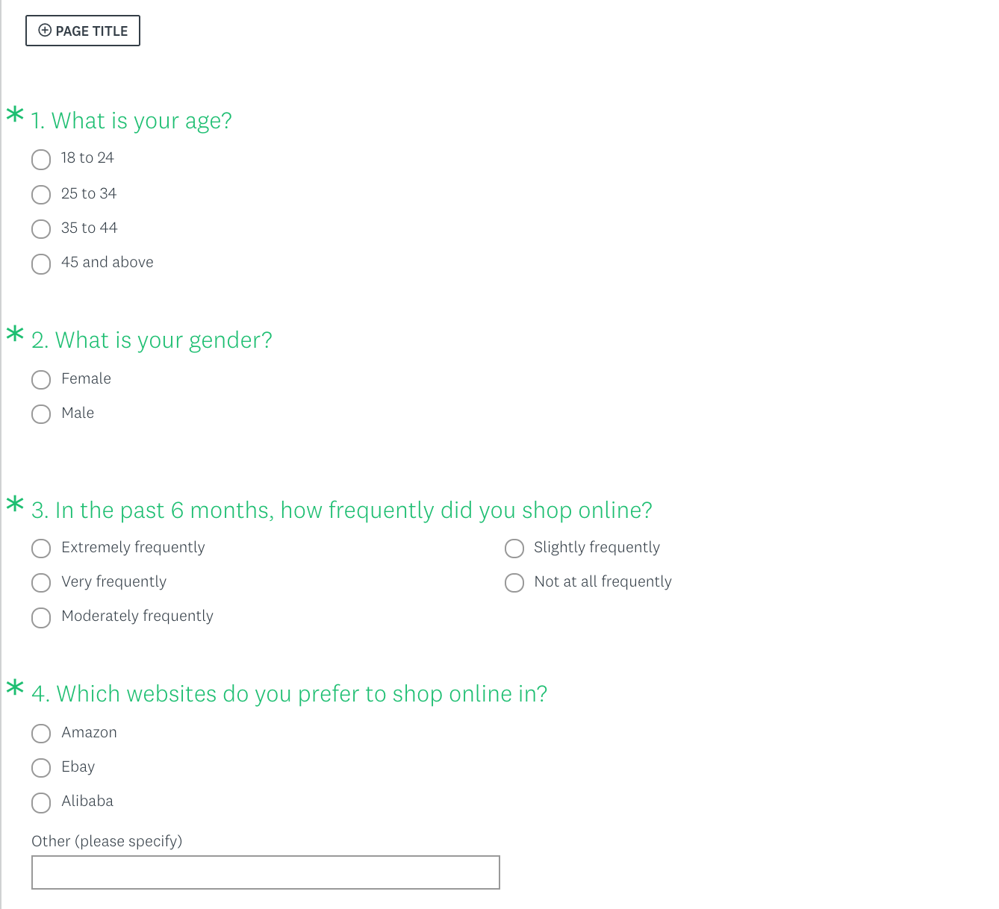

##### Figure 13. Survey questions #1.

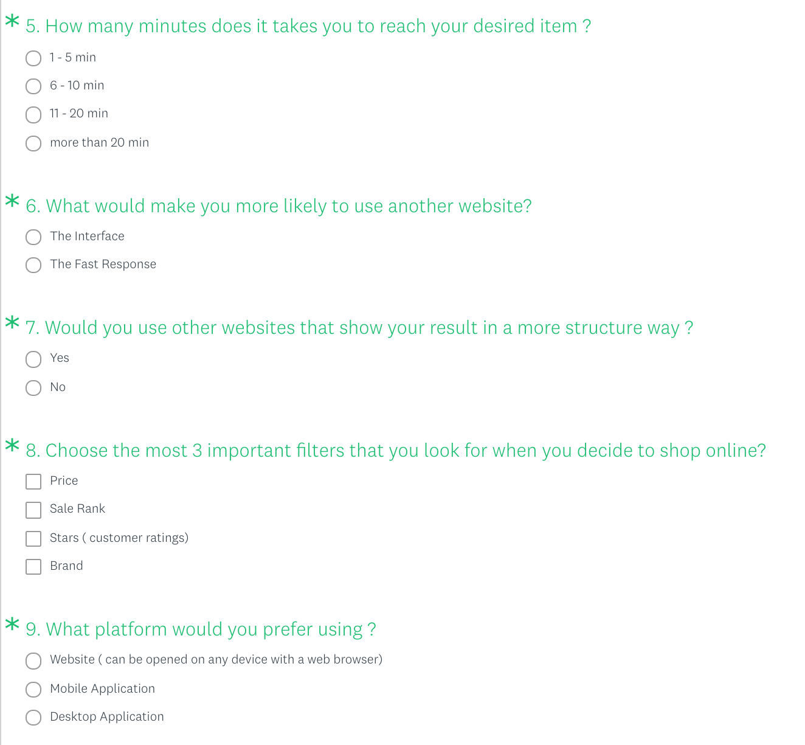

##### Figure 14. Survey questions #2.

* Questions Analysis:
* Analysis of Question # 1:

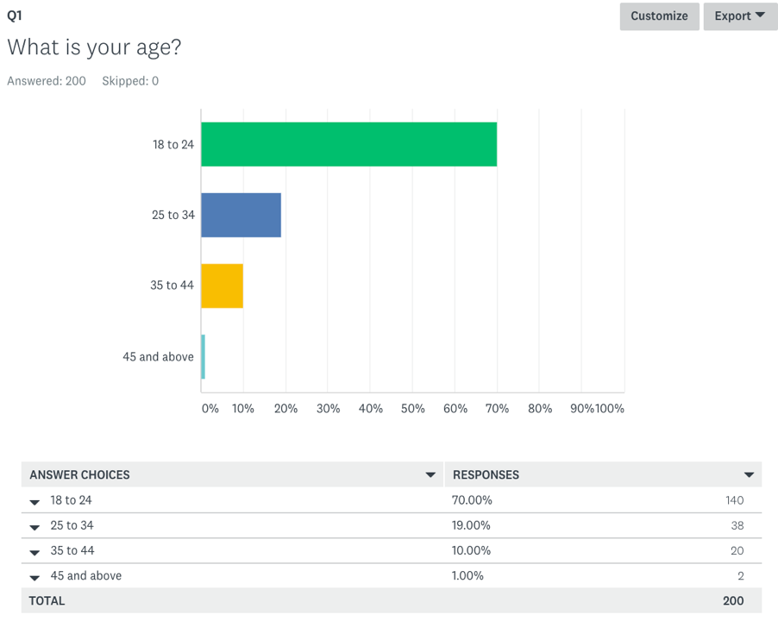

##### Figure 15. Analysis of Question # 1.

* Analysis of Question # 2:

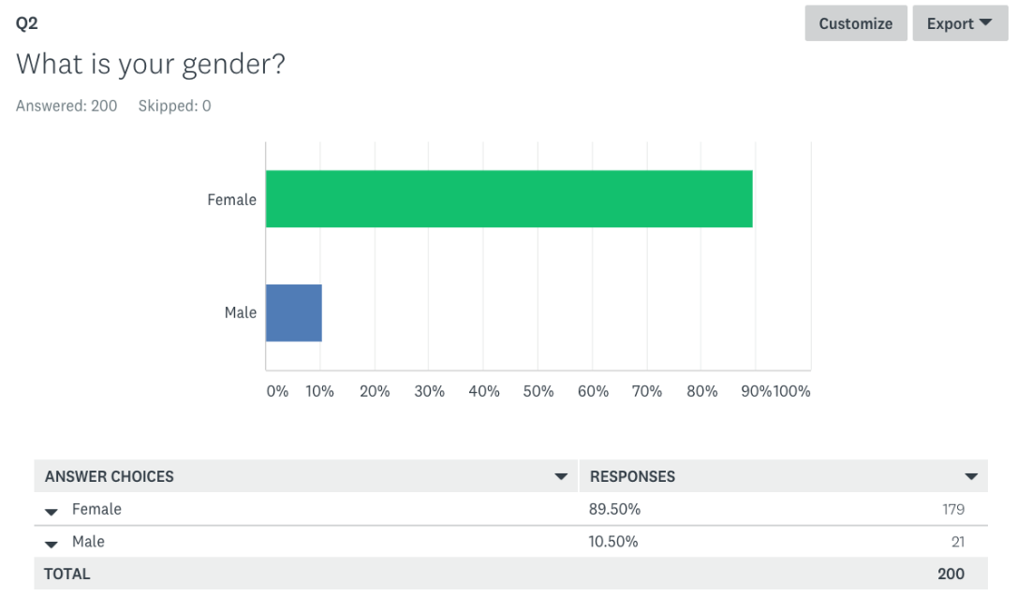

##### Figure 16. Analysis of Question # 2.

Analysis of Question # 3:

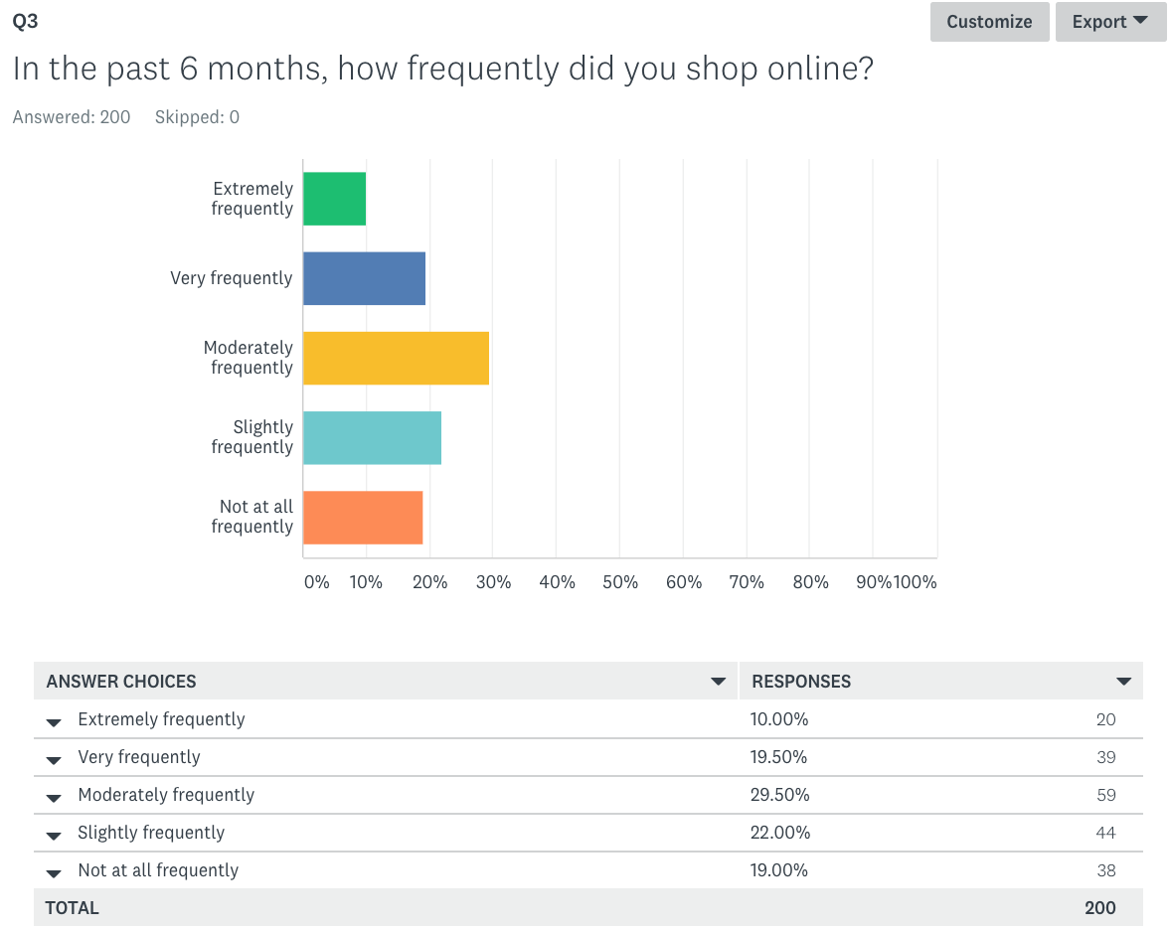

##### Figure 17. Analysis of Question # 3.

* Analysis of Question # 4:

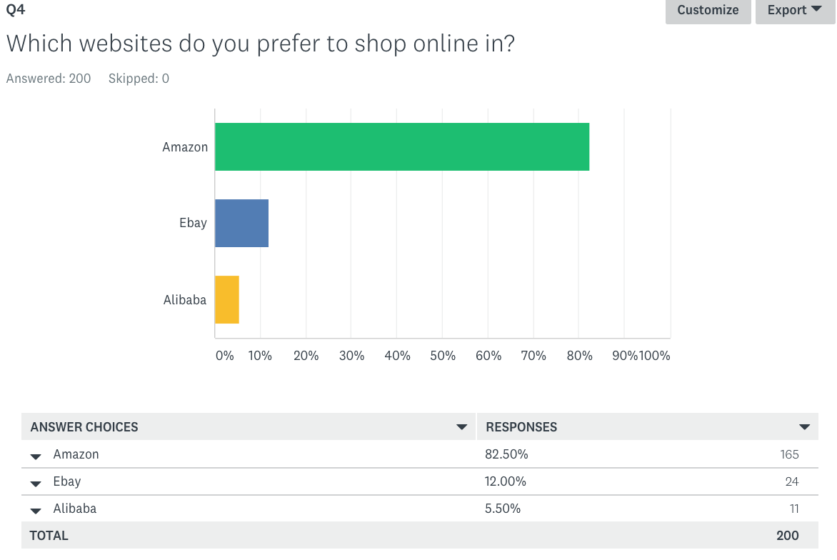

##### Figure 18. Analysis of Question # 4.

* Analysis of Question # 5:

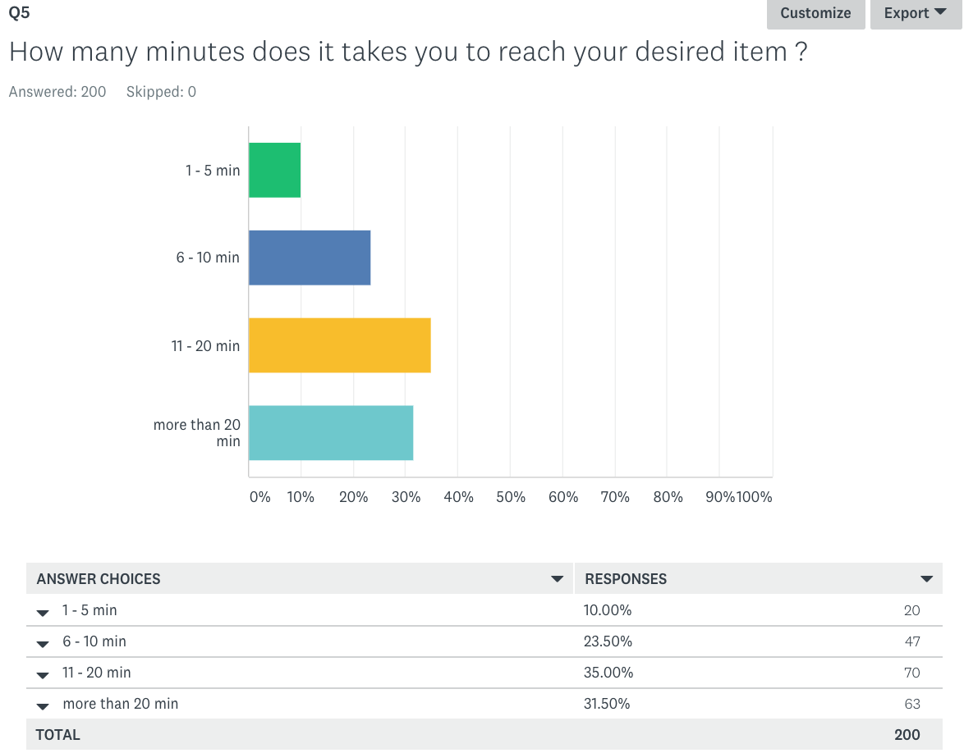

##### Figure 19. Analysis of Question # 5.

* Analysis of Question # 6:

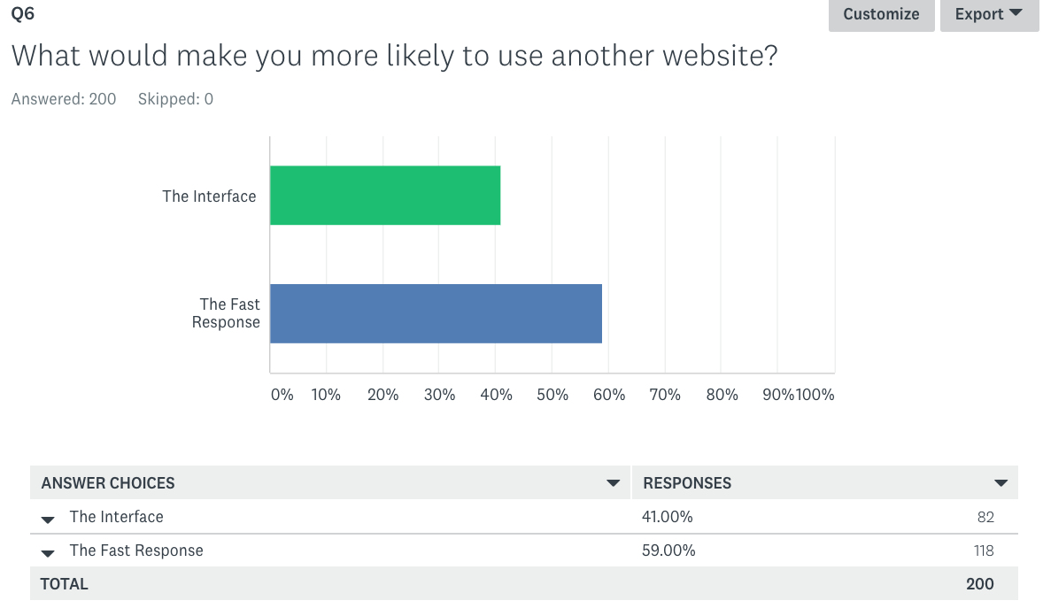

##### Figure 20. Analysis of Question # 6.

* Analysis of Question # 7:

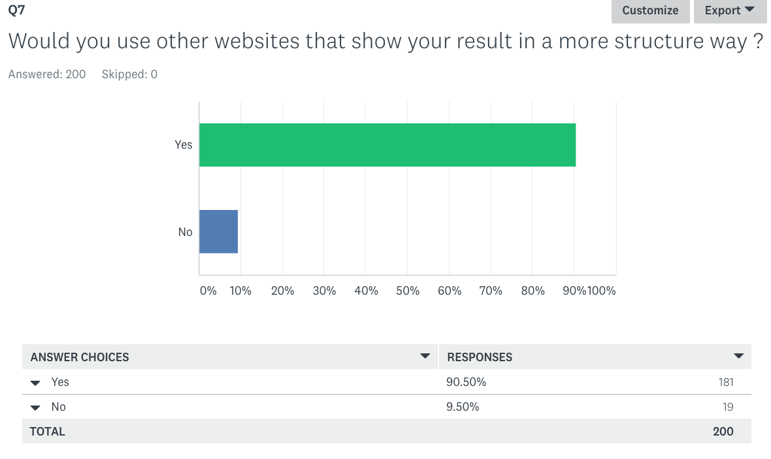

##### Figure 21. Analysis of Question # 7.

* Analysis of Question # 8:

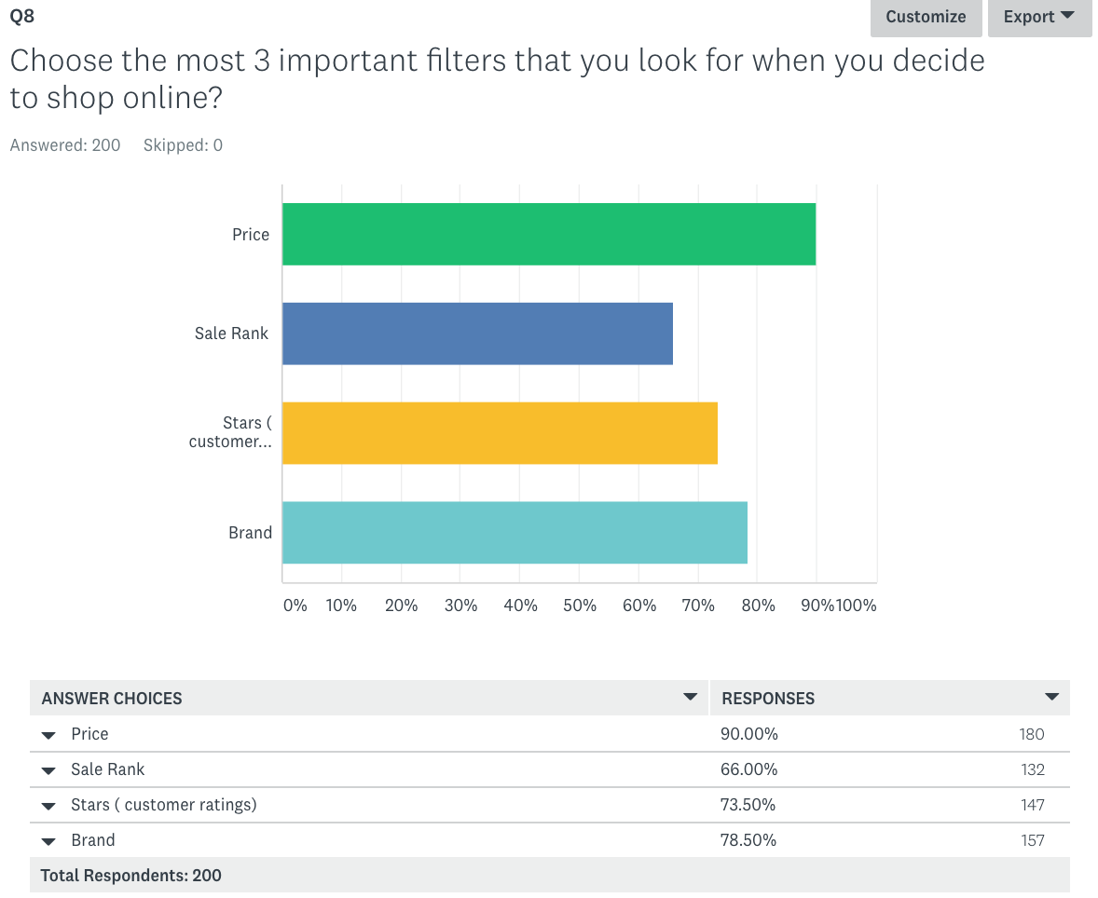

##### Figure 22. Analysis of Question # 8.

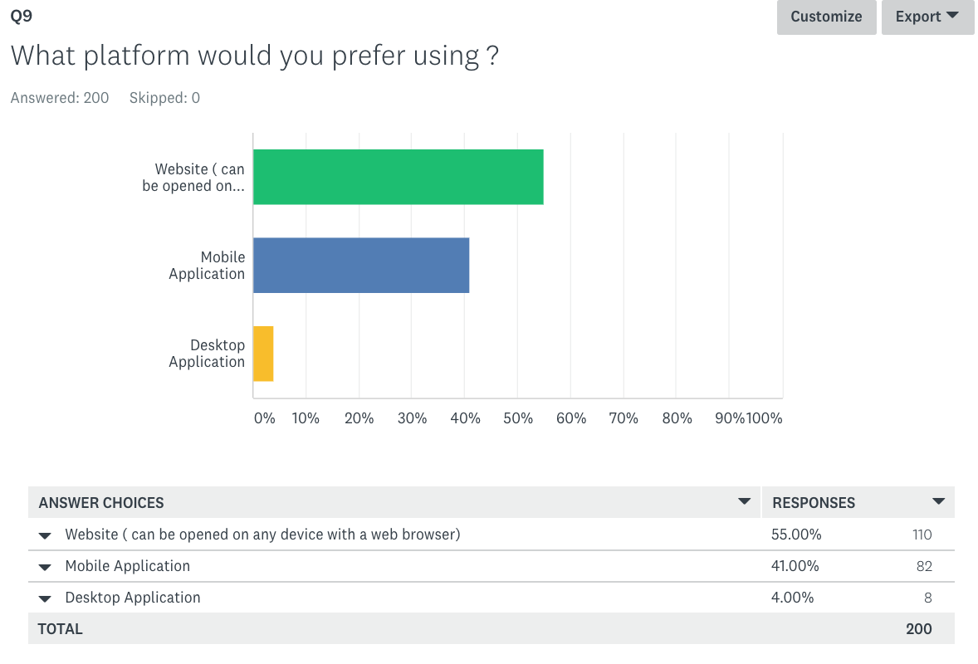

##### Figure 23. Analysis of Question # 9.

# Appendix c – detailed class diagram

AdapterPattern:

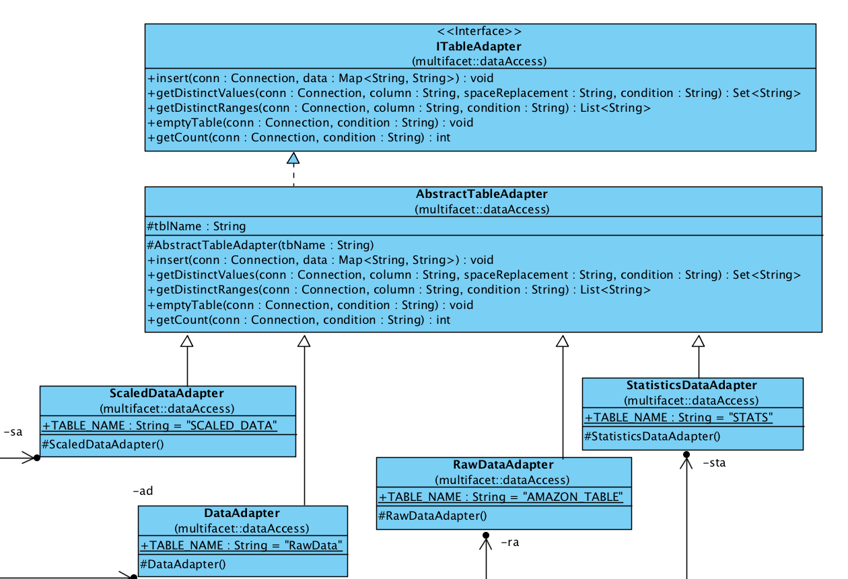

amazonapiDbproxy:

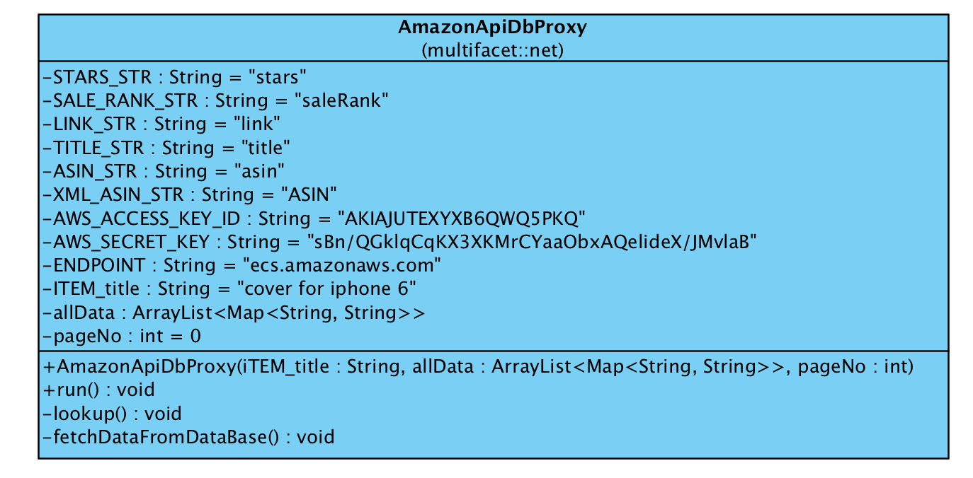

amazonApiproxy:

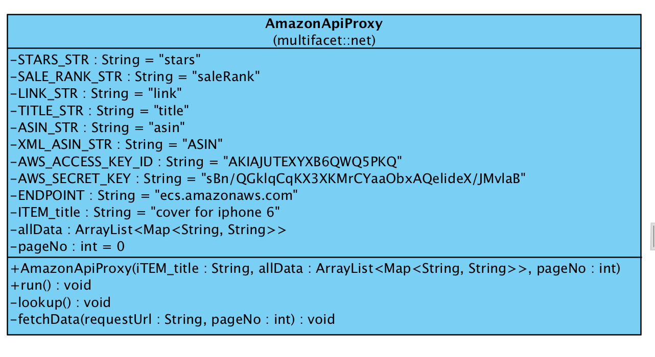

Commands1:

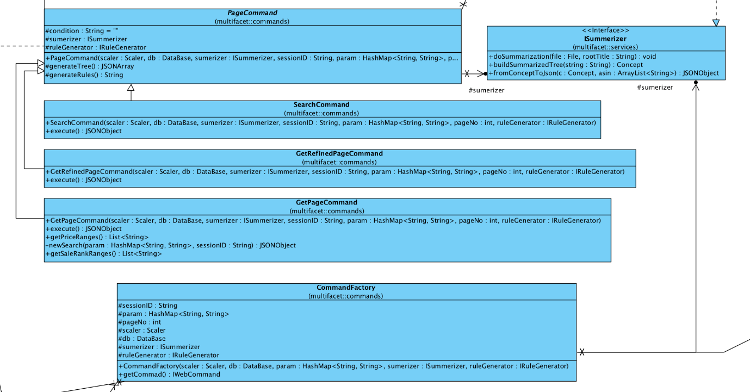

Commands2:

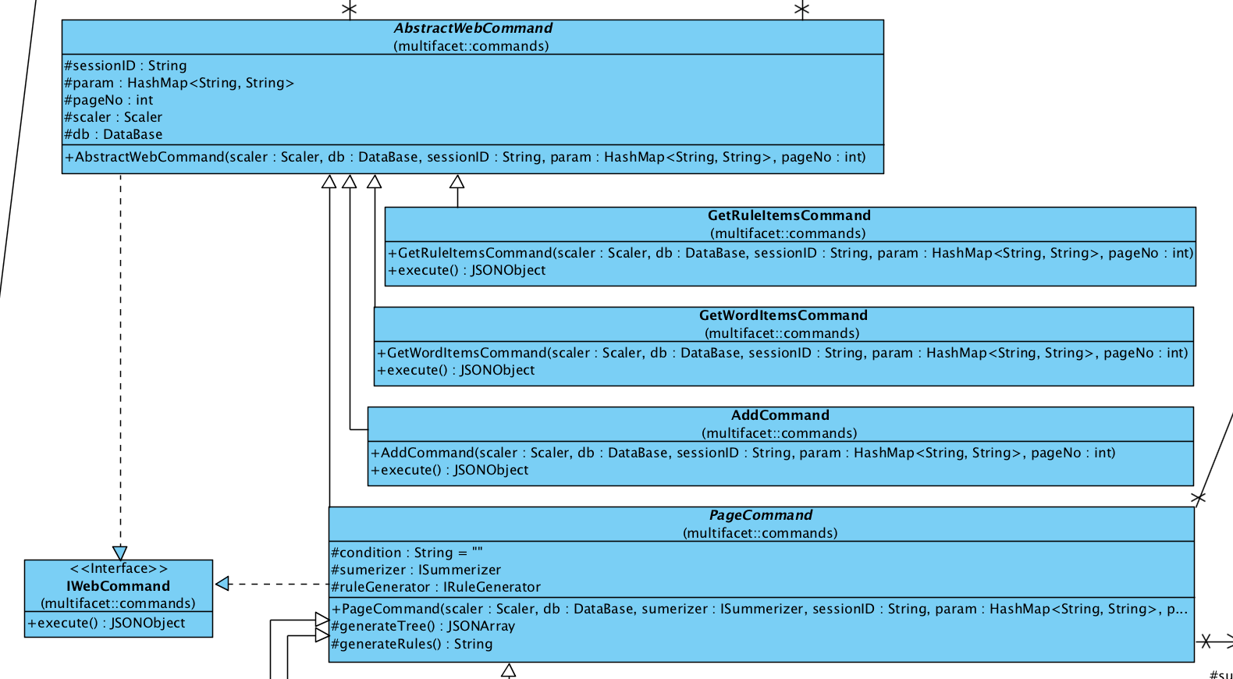

Database:

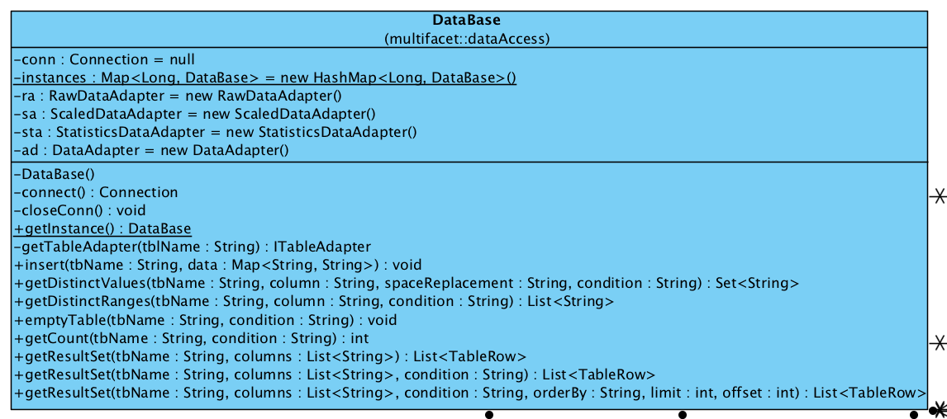

Ebayproxy:

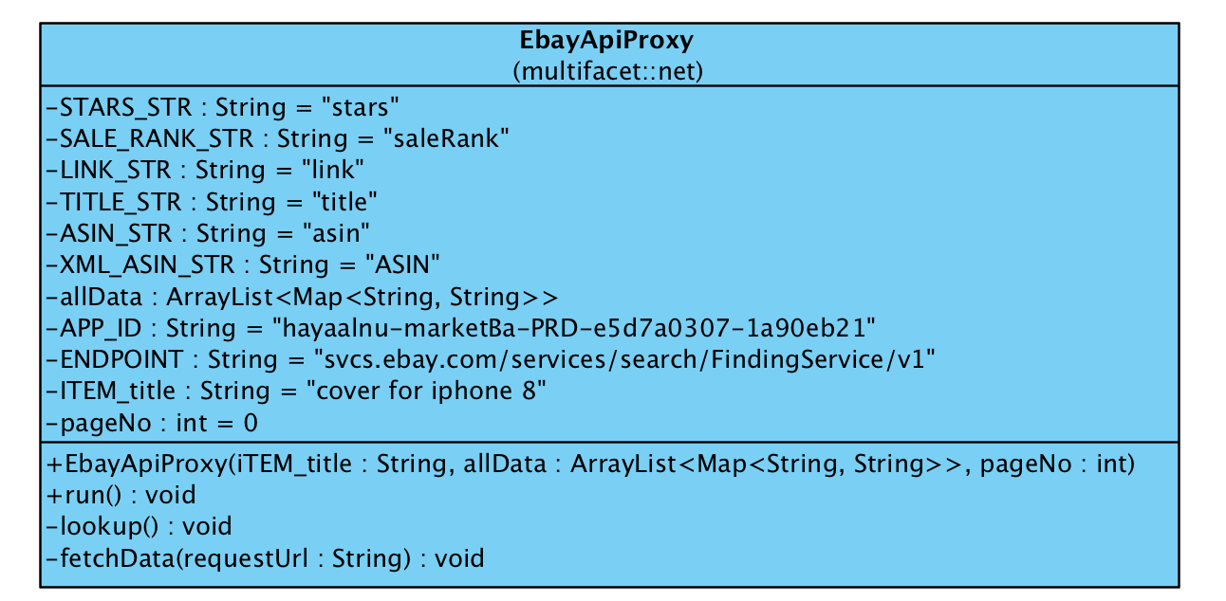

IruleGenerator:

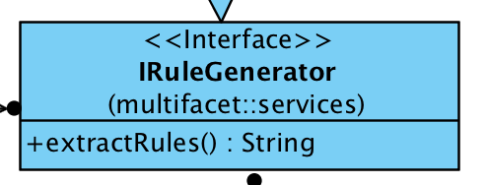

Maputil

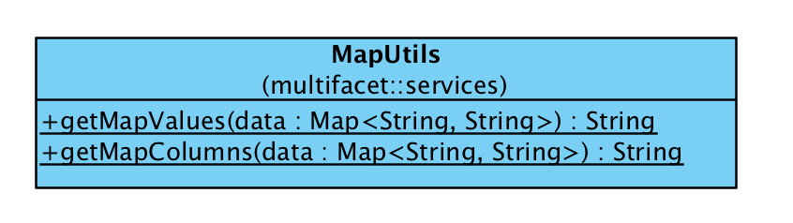

Mbaserver

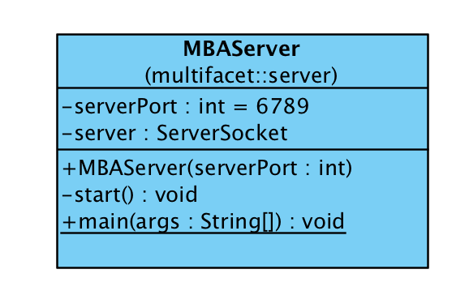

MBAService:

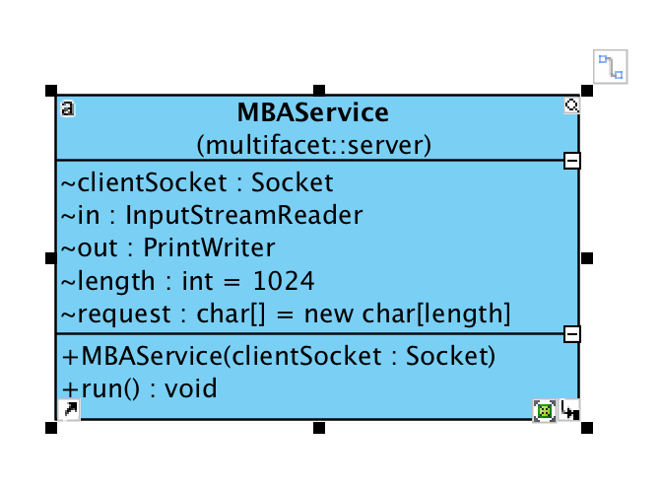

rulesGen:

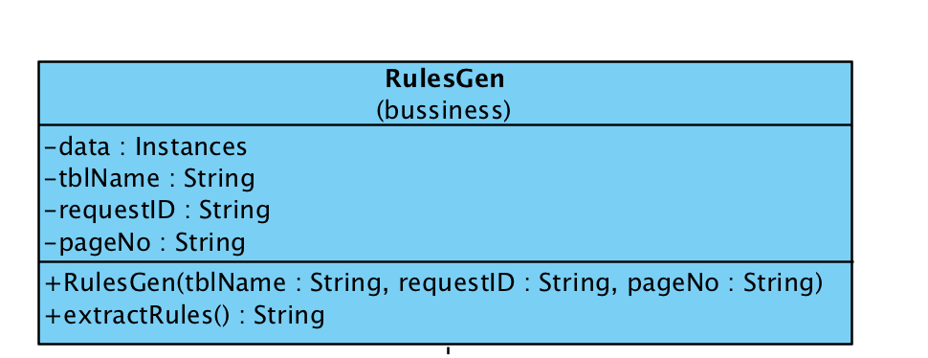

Sanitizer:

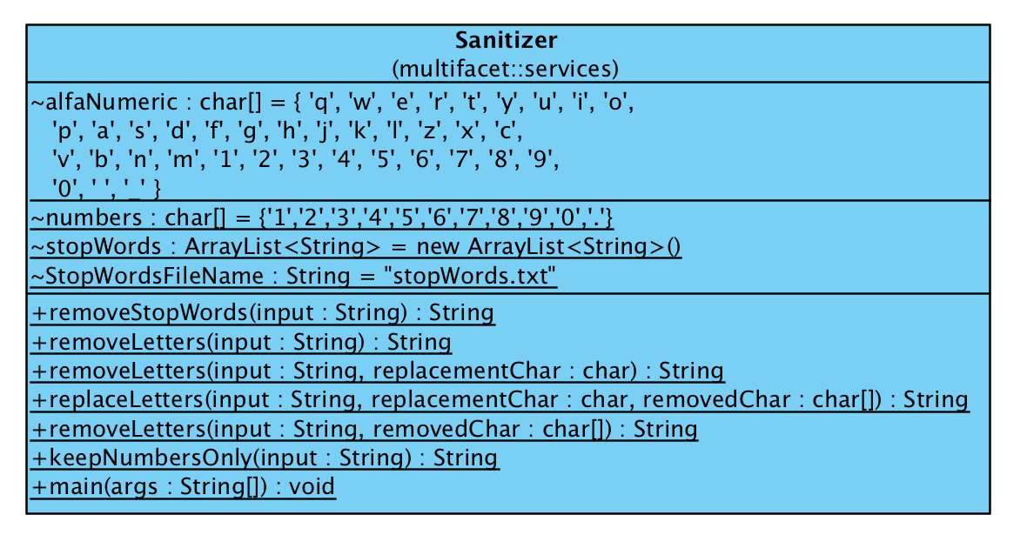

SignedRequestHelper:

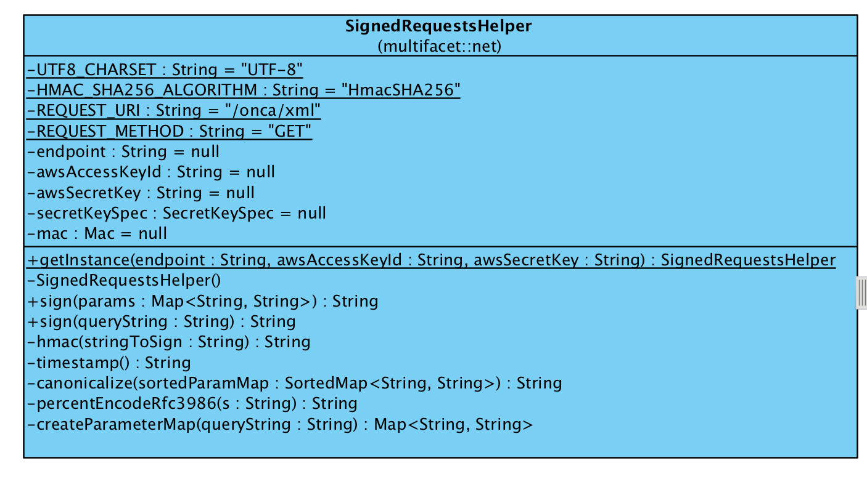

tableRow:

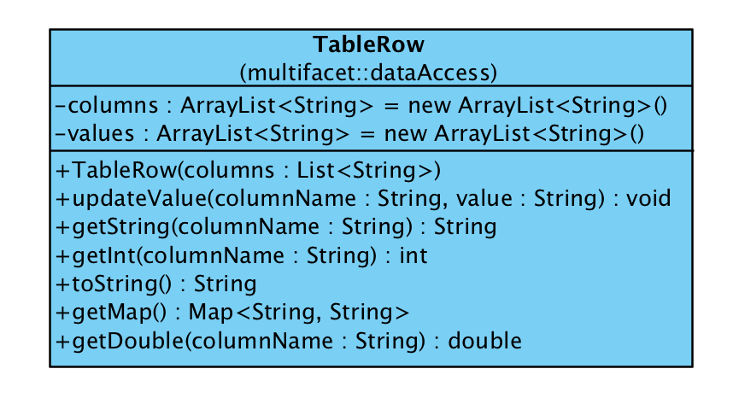

urlConnection:



webController:

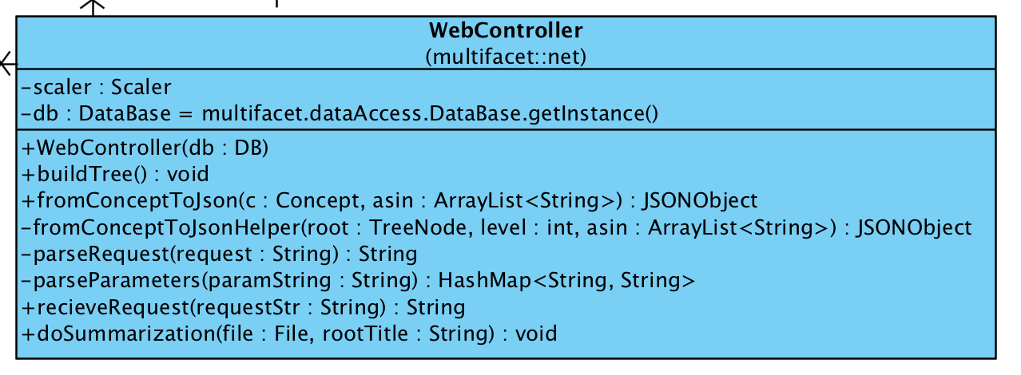

# Other Appendices